26.04.2023

20 нейронов

1. nn = **20**, n_train = 200, n_test = 200, k = 0.99945, tau_const = 3.5,

g_const = 3.0/ni(train), 3.1/ni(clf+test), learning_rate = **0.25**

Training time: 231.8979799747467

Actual number of training set: 98

Number of neurons, reacting to the corresponding image: {'4': 2, 'None': 8, '8': 1, '7': 3, '2': 1, '9': 1, '1': 1, '5': 2, '3': 1}

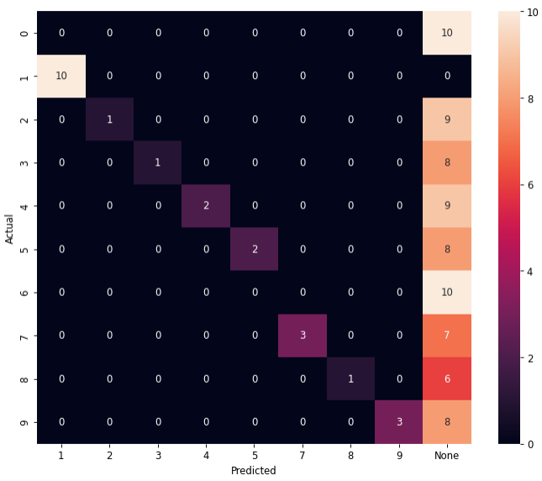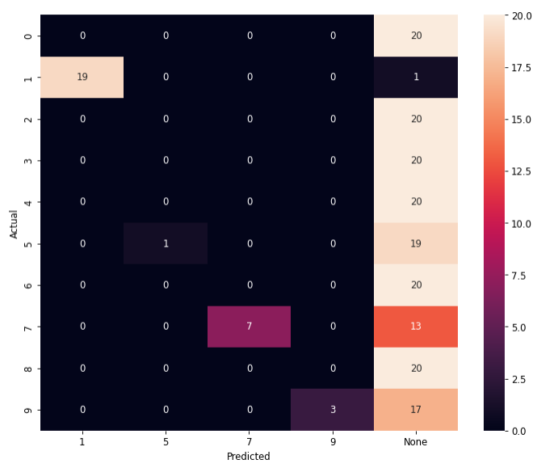

F1_score (train): 0.235 F1_score (test): 0.15

1. nn = **20**, n_train = 200, n_test = 200, k = 0.99945, tau_const = 3.5,

g_const = 3.0/ni(train), 3.1/ni(clf+test), learning_rate = **0.3**

Training time: 144.21554851531982

Actual number of training set: 62

Number of neurons, reacting to the corresponding image: {'7': 3, '6': 2, '2': 3, '1': 3, '9': 4, '0': 2, '5': 2, '8': 1}

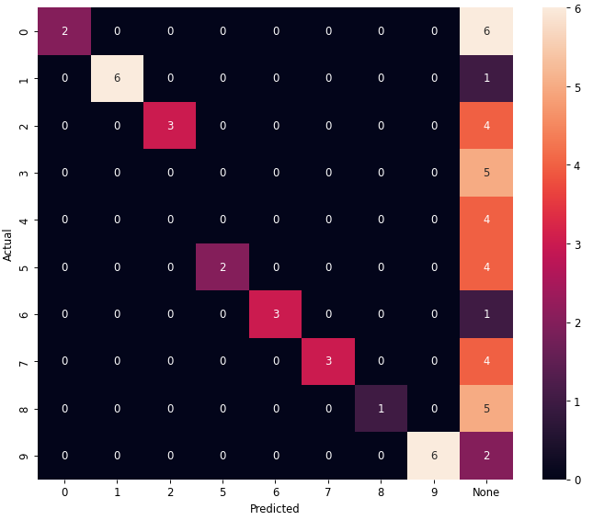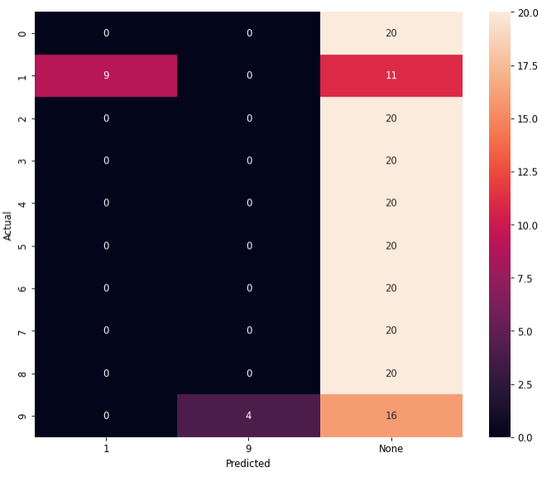

F1_score (train): 0.419 F1_score (test): 0.065

30 нейронов

1. nn = 30, n_train = 1000, n_test = 200, k = 0.99945, tau_const = 3.5,

g_const = **3.0**/ni(train), 3.1/ni(clf), 3.1/ni(test), learning_rate = **0.25**

Training time:

Actual number of training set: 132

Number of neurons, reacting to the corresponding image: {'None': 23, '9': 3, '5': 2, '3': 1, '1': 1}

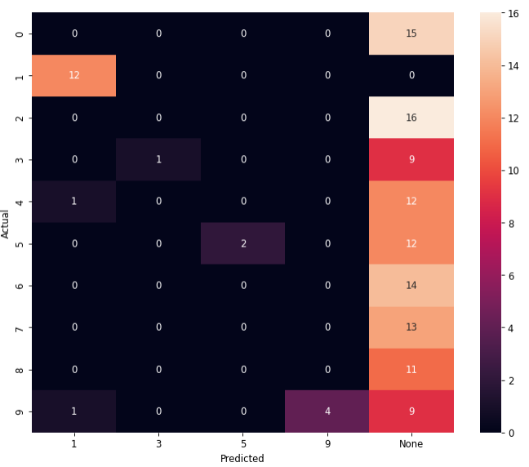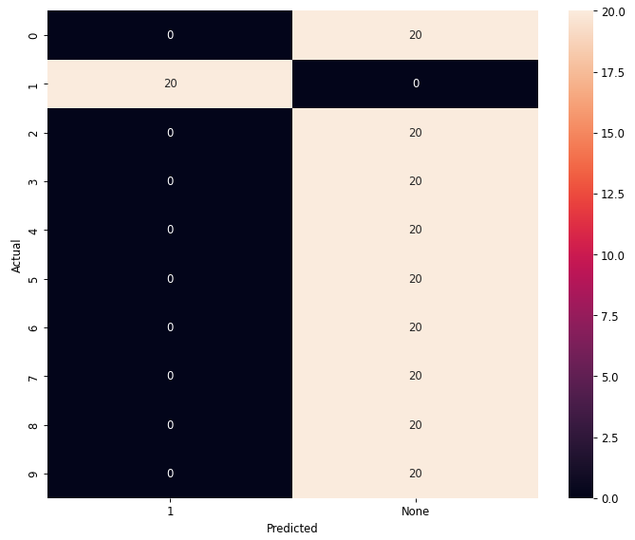

F1_score (train): F1_score (test): 0.1

g_const = **3.0**/ni(train), 3.5/ni(clf), 3.5/ni(test), learning_rate = **0.25**

Training time: 347.87817120552063

Actual number of training set: 122

Number of neurons, reacting to the corresponding image: {'3': 4, '1': 1, '2': 1, '6': 2, 'None': 4, '4': 3, '7': 4, '0': 3, '9': 4, '5': 2, '8': 2}

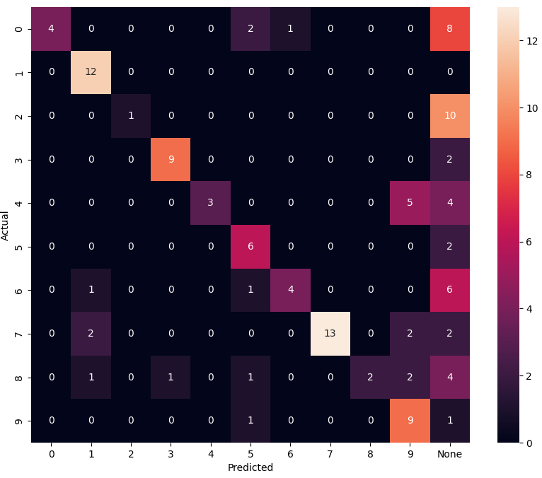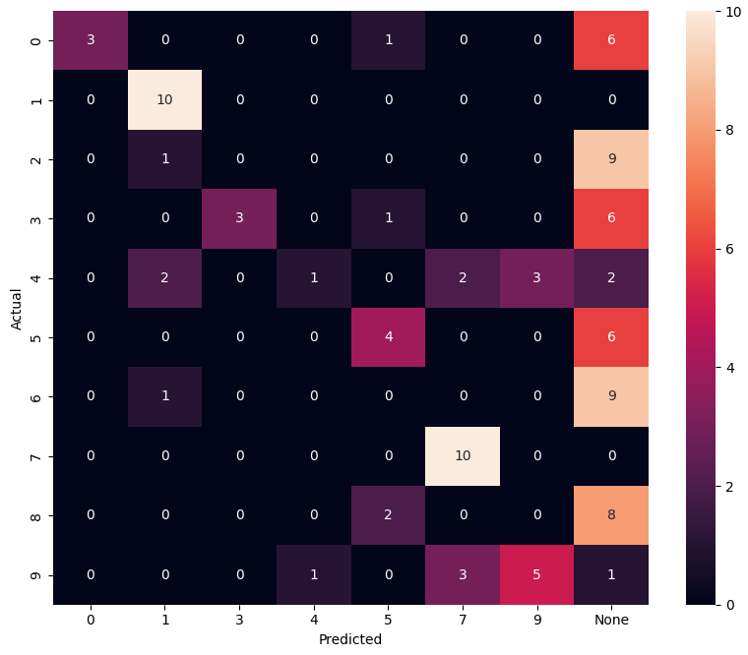

F1_score (train): 0.51 F1_score (test): 0.36

1. nn = 30, n_train = 1000, n_test = 200, k = 0.99945, tau_const = 3.5,

g_const = **2.9**/ni(train), 3.1/ni(clf), 3.1/ni(test), learning_rate = **0.25**

Training time: 1586.318600654602

Actual number of training set: 372

Number of neurons, reacting to the corresponding image: {'None': 6, '4': 5, '7': 4, '9': 5, '3': 1, '6': 4, '8': 2, '5': 1, '1': 2}

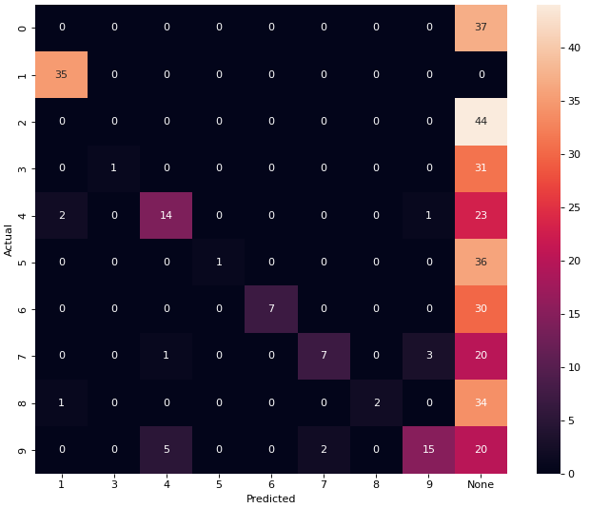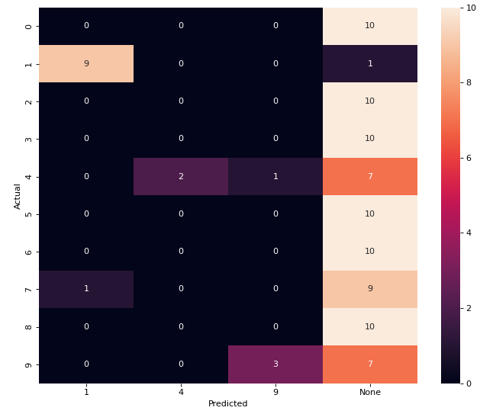

F1_score (train): 0.22 F1_score (test): 0.14

g_const = **2.9**/ni(train), 3.5/ni(clf), 3.5/ni(test), learning_rate = **0.25**

Number of neurons, reacting to the corresponding image: {'7': 3, '4': 6, 'None': 4, '9': 4, '3': 3, '6': 5, '8': 3, '2': 1, '1': 1}

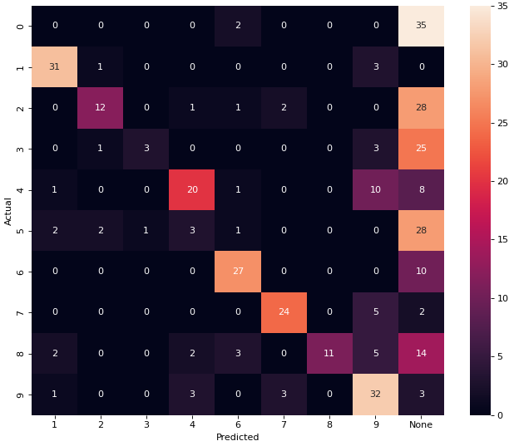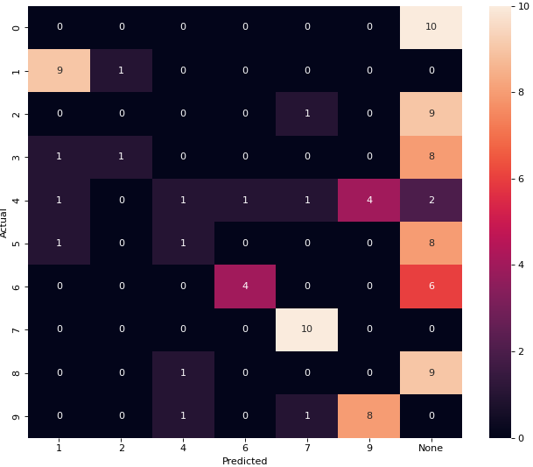

F1_score (train): 0.43 F1_score (test): 0.32

1. nn = 30, n_train = 1000, n_test = 100, k = 0.99945, tau_const = 3.5,

g_const = **3.0**/ni(train), 3.1/ni(clf), 3.1/ni(test), learning_rate = **0.3**

Training time: 289.8684859275818

Actual number of training set: 101

Number of neurons, reacting to the corresponding image: {'3': 3, '1': 2, '0': 4, '7': 6, '2': 4, '9': 4, '8': 1, '6': 2, '5': 2, '4': 2}

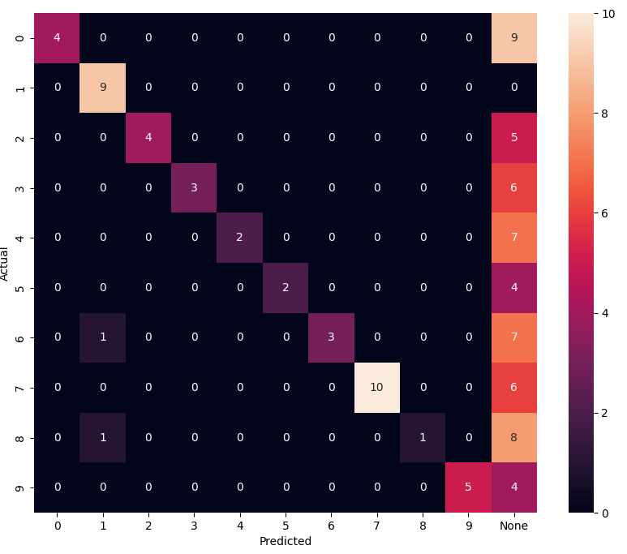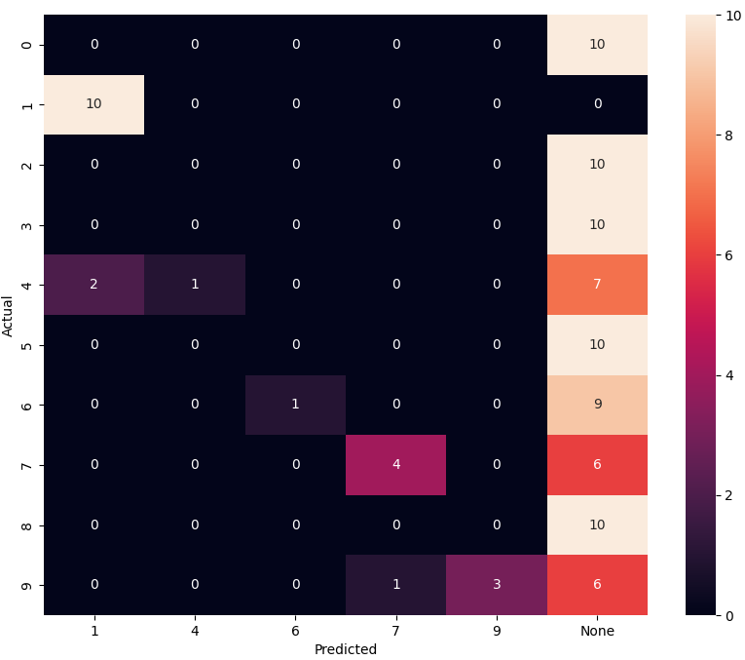

F1_score (train): 0.426 F1_score (test): 0.19

g_const = **3.0**/ni(train), 3.5/ni(clf), 3.5/ni(test), learning_rate = **0.3**

Training time: 581.3283181190491

Actual number of training set: 133

Number of neurons, reacting to the corresponding image: {'None': 14, '5': 1, '8': 2, '9': 2, '6': 2, '7': 2, '3': 2, '0': 3, '1': 1, '4': 1}

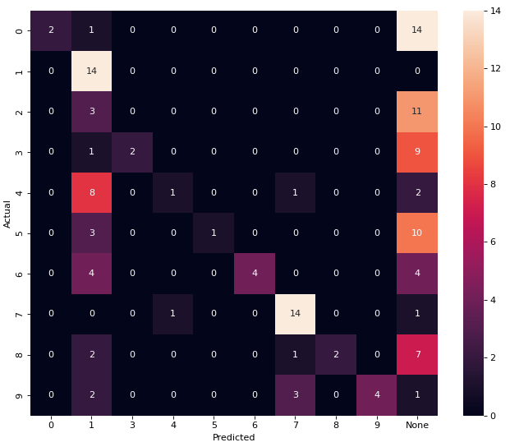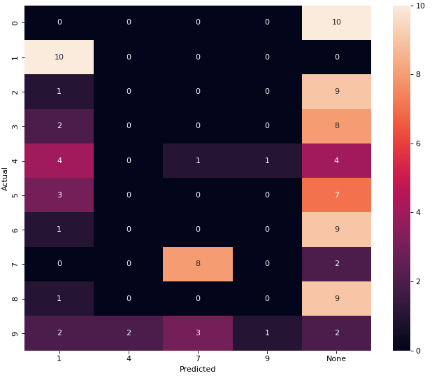

F1_score (train): 0.33 F1_score (test): 0.19

1. nn = 30, n_train = 1000, n_test = 100, k = 0.99945, tau_const = 3.5,

g_const = **2.9**/ni(train), 3.1/ni(clf), 3.1/ni(test), learning_rate = **0.3**

Training time: 358.4720730781555

Actual number of training set: 121

Number of neurons, reacting to the corresponding image: {'5': 1, 'None': 21, '3': 2, '7': 2, '0': 1, '1': 2, '8': 1}

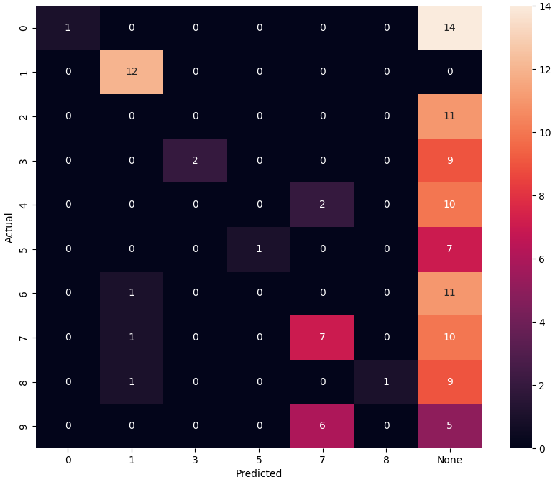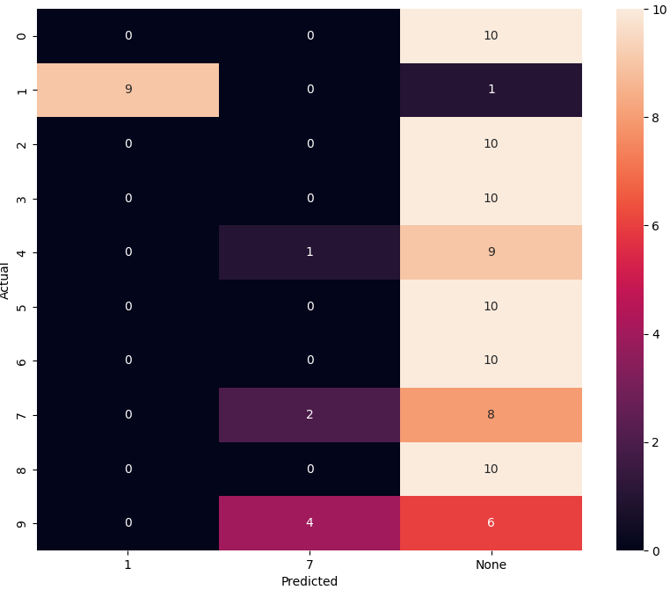

F1_score (train): 0.2 F1_score (test): 0.11

g_const = **2.9**/ni(train), 3.5/ni(clf), 3.5/ni(test), learning_rate = **0.3**

Training time: 358.4720730781555

Actual number of training set: 121

Number of neurons, reacting to the corresponding image: {'5': 1, '6': 2, 'None': 16, '7': 2, '8': 2, '0': 2, '1': 2, '3': 3}

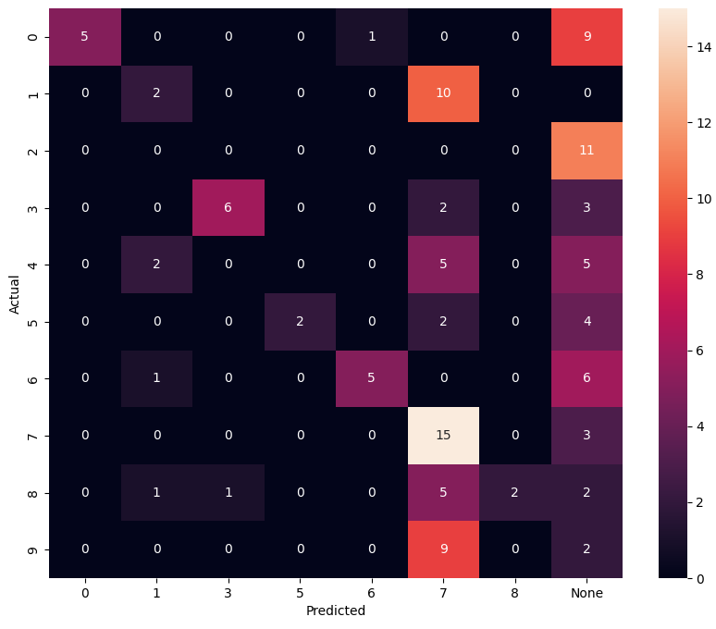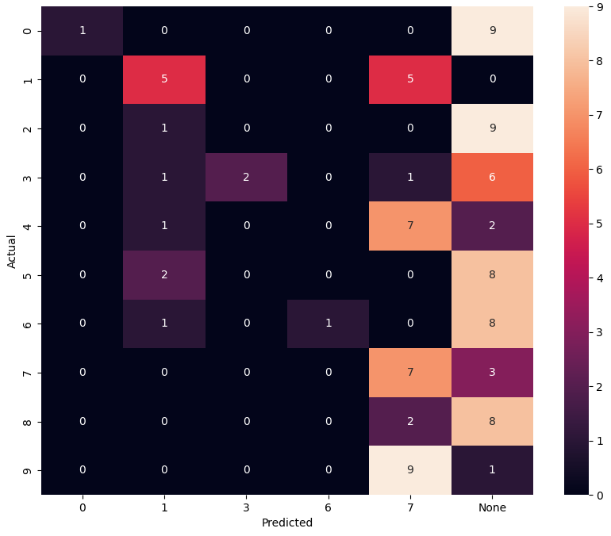

F1_score (train): 0.31 F1_score (test): 0.16

27.04.2023

***k changing***

1. nn = 30, n_train = 1000, n_test = 100, k = **0.99945**, tau_const = 3.5,

g_const = **3.0**/ni(train), **3.1**/ni(clf), **3.1**/ni(test), learning_rate = **0.25**

Training time: 625.4438707828522

Actual number of training set: 146

Number of neurons, reacting to the corresponding image: {'9': 5, '3': 3, '5': 3, '4': 5, '6': 4, '0': 4, '7': 5, '1': 1}

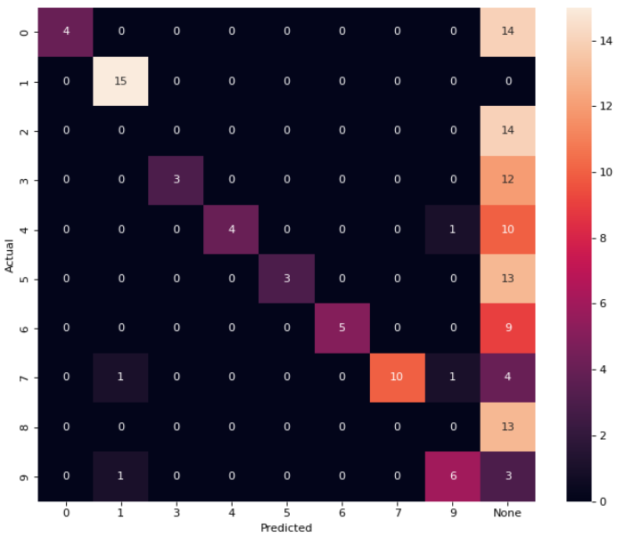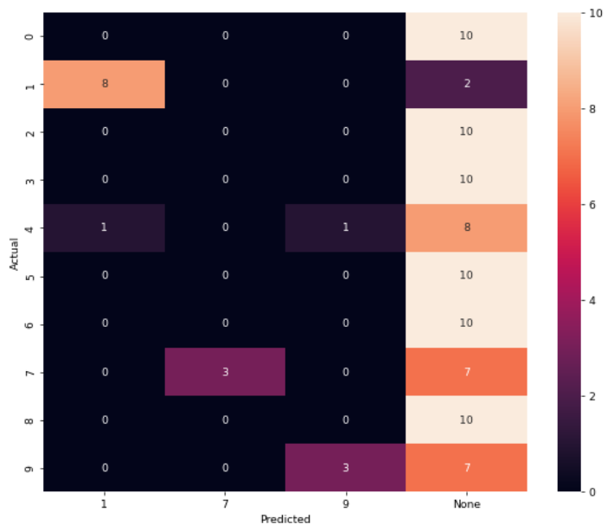

F1_score (train): 0.34 F1_score (test): 0.14

g_const = **3.0**/ni(train), **3.5**/ni(clf), **3.5**/ni(test), learning_rate = **0.25**

Training time: 625.4438707828522

Actual number of training set: 146

Number of neurons, reacting to the corresponding image: {'1': 3, '3': 3, '9': 2, '5': 4, '4': 4, 'None': 3, '6': 3, '0': 4, '7': 3, '2': 1}

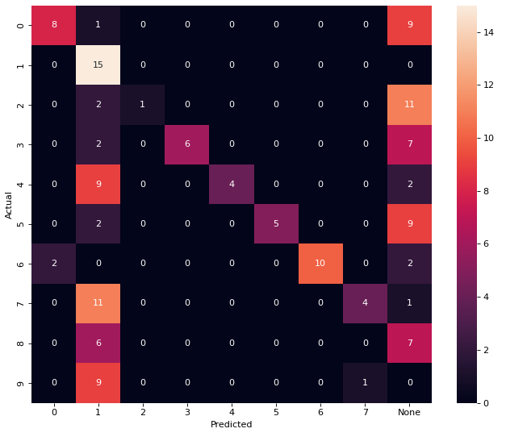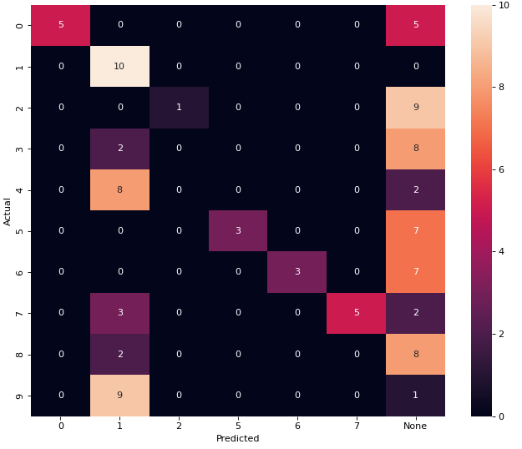

F1_score (train): 0.36 F1_score (test): 0.27

1. nn = 30, n_train = 1000, n_test = 100, k = **0.9992**, tau_const = 3.5,

g_const = **3.0**/ni(train), **3.1**/ni(clf), **3.1**/ni(test), learning_rate = **0.25**

Training time: 426.1536810398102

Actual number of training set: 99

Number of neurons, reacting to the corresponding image: {'9': 2, '7': 6, 'None': 1, '0': 4, '2': 4, '6': 5, '8': 1, '5': 2, '4': 2, '1': 1, '3': 2}

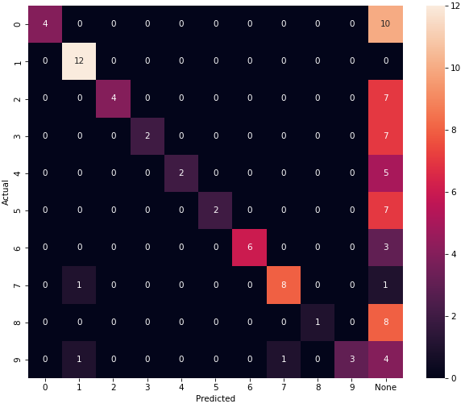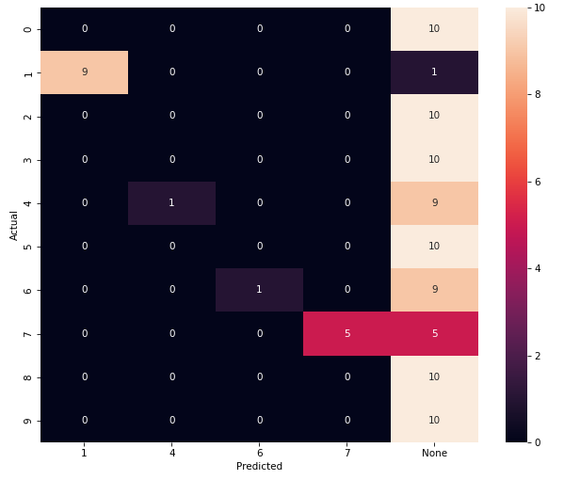

F1_score (train): 0.444 F1_score (test): 0.16

g_const = **3.0**/ni(train), **3.5**/ni(clf), **3.5**/ni(test), learning_rate = **0.25**

Training time: 426.1536810398102

Actual number of training set: 99

Number of neurons, reacting to the corresponding image: {'9': 2, '7': 6, 'None': 2, '0': 4, '2': 4, '5': 2, '8': 1, '6': 4, '4': 2, '1': 1, '3': 2}

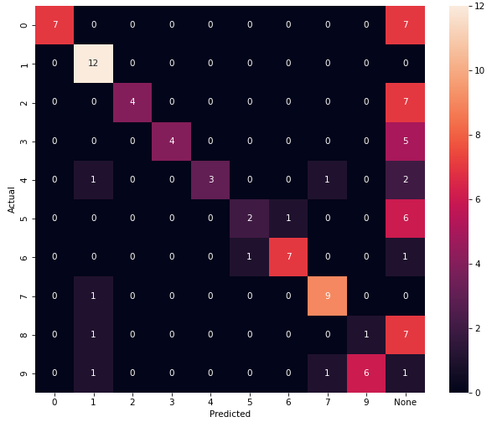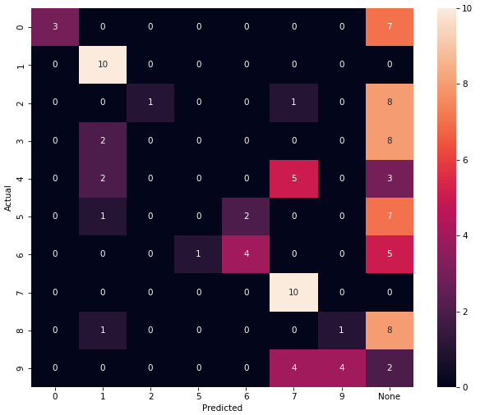

F1_score (train): 0.5454 F1_score (test): 0.32

1. nn = 30, n_train = 1000, n_test = 100, k = **0.9996**, tau_const = 3.5,

g_const = **3.0**/ni(train), **3.1**/ni(clf), **3.1**/ni(test), learning_rate = **0.25**

Training time: 489.51855635643005

Actual number of training set: 171

Number of neurons, reacting to the corresponding image: {'7': 6, '0': 3, '5': 1, '8': 2, '2': 4, '3': 3, '6': 3, '9': 2, '4': 2, '1': 3, 'None': 1}

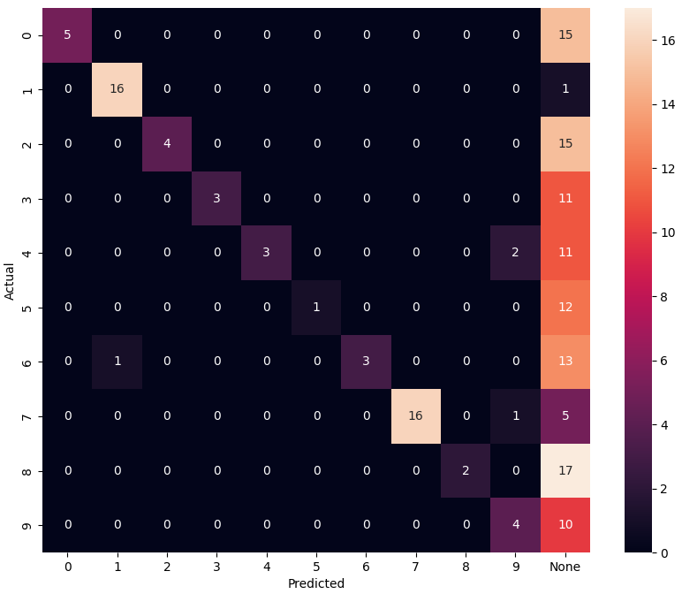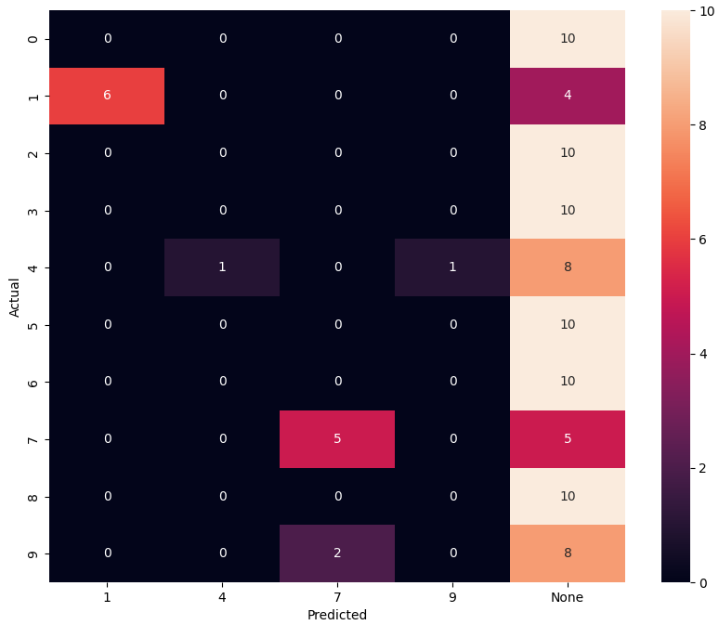

F1_score (train): 0.33 F1_score (test): 0.12

g_const = **3.0**/ni(train), **3.5**/ni(clf), **3.5**/ni(test), learning_rate = **0.25**

Training time: 489.51855635643005

Actual number of training set: 171

Number of neurons, reacting to the corresponding image: {'7': 5, '0': 3, '4': 3, '5': 2, '8': 2, '2': 4, '3': 2, '6': 3, '9': 3, '1': 3}

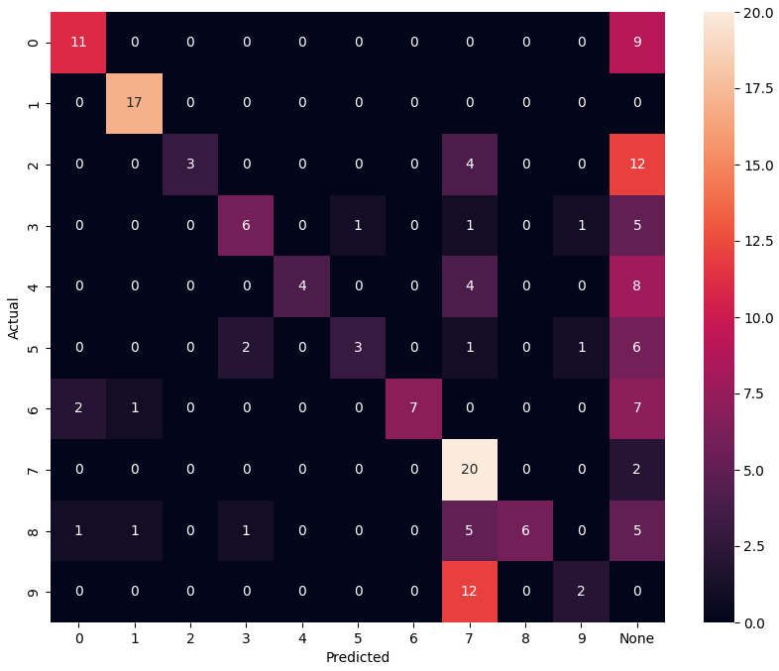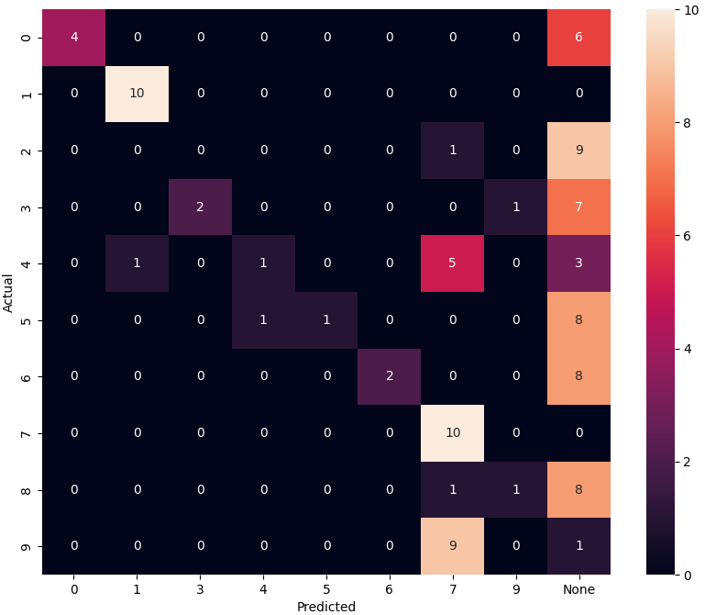

F1_score (train): 0.46 F1_score (test): 0.3

1. nn = 30, n_train = 1000, n_test = 100, k = **0.99**, tau_const = 3.5,

g_const = **3.0**/ni(train), **3.5**/ni(clf), **3.5**/ni(test), learning_rate = **0.25**

Training time: 233.82868266105652

Actual number of training set: 54

Number of neurons, reacting to the corresponding image: {'9': 1, '5': 6, 'None': 4, '2': 6, '1': 1, '4': 3, '0': 3, '8': 1, '3': 1, '7': 2, '6': 2}

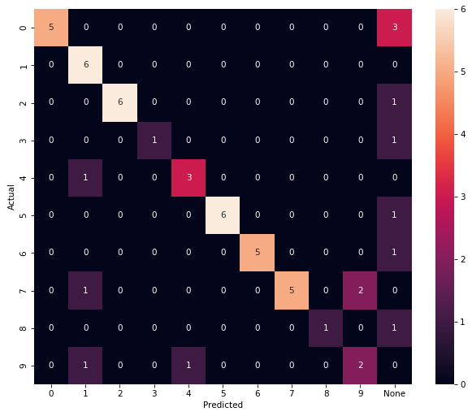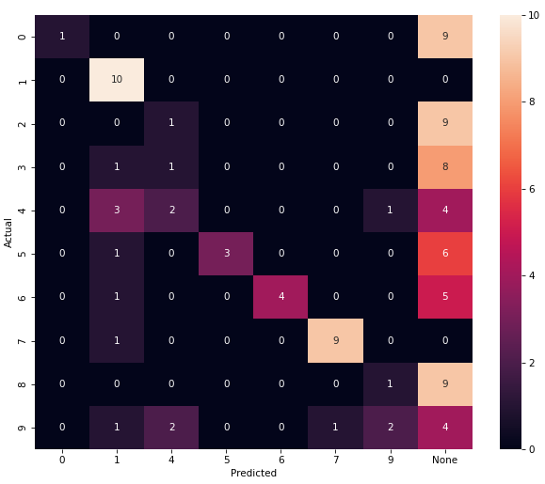

F1_score (train): 0.74 F1_score (test): 0.31

(на g_const = **3.1**/ni(train) примерно так же)

1. nn = 30, n_train = 1000, n_test = 100, k = **0.995**, tau_const = 3.5,

g_const = **3.0**/ni(train), **3.5**/ni(clf), **3.5**/ni(test), learning_rate = **0.25**

Training time: 248.63249111175537

Actual number of training set: 55

Number of neurons, reacting to the corresponding image: {'7': 5, '6': 4, 'None': 2, '2': 4, '5': 5, '1': 2, '0': 2, '8': 1, '4': 3, '9': 1, '3': 1}

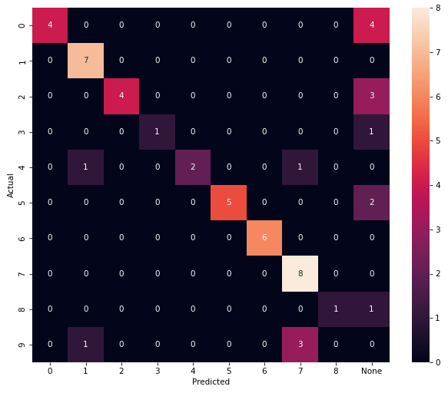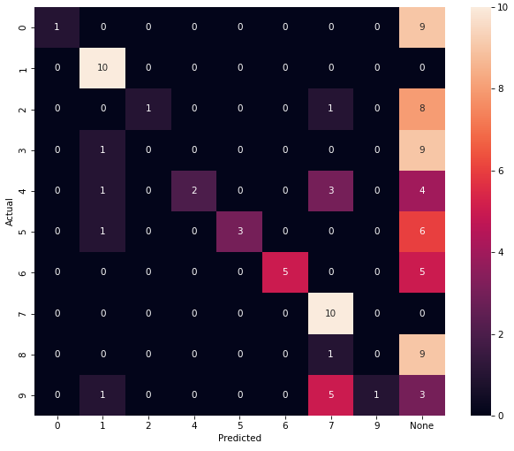

F1_score (train): 0.69 F1_score (test): 0.33

1. nn = 30, n_train = 1000, n_test = 100, k = **0.9997**, tau_const = 3.5,

g_const = **3.0**/ni(train), **3.5**/ni(clf), **3.5**/ni(test), learning_rate = **0.25**

Training time: 481.5165979862213

Actual number of training set: 168

Number of neurons, reacting to the corresponding image: {'5': 1, '2': 3, '6': 4, '0': 3, '7': 4, '8': 6, '1': 1, '4': 3, 'None': 2, '9': 2, '3': 1}

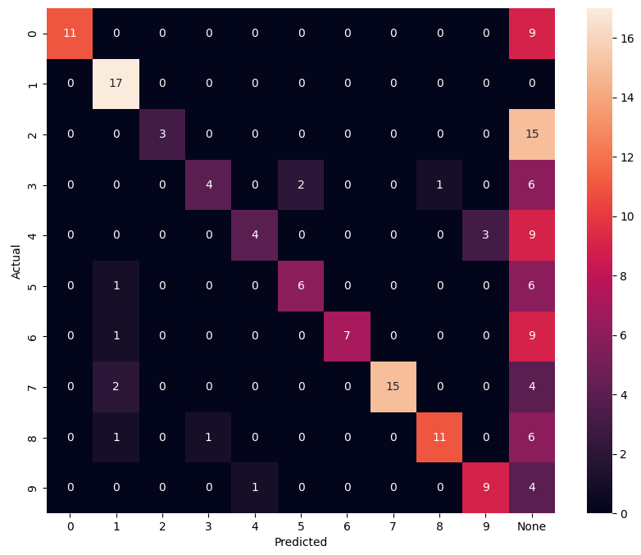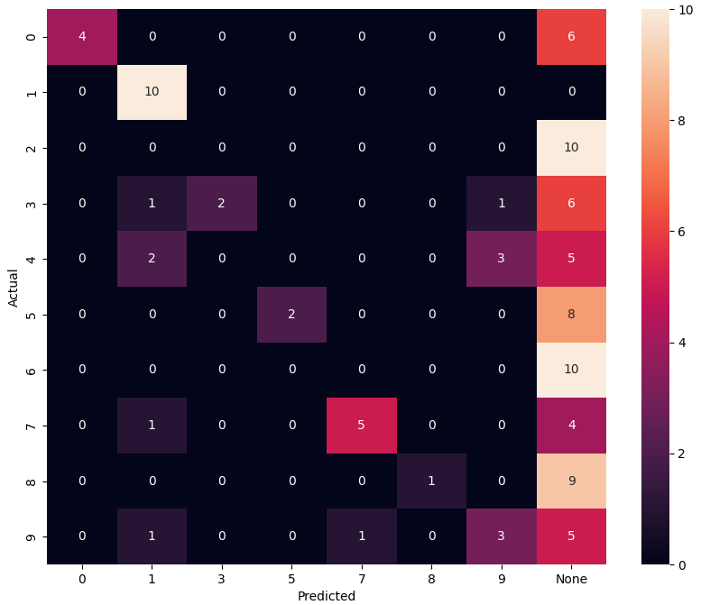

F1_score (train): 0.5178 F1_score (test): 0.27

**число нейронов**

1. **nn = 40**, n_train = 1000, n_test = 300, k = 0.99, tau_const = 3.5,

g_const = **3.1**/ni(train), **3.5**/ni(clf), **3.5**/ni(test), learning_rate = **0.25**

Training time: 563.8447906970978

Actual number of training set: 117

Number of neurons, reacting to the corresponding image: {'7': 3, '0': 3, '2': 6, '8': 5, '4': 4, '6': 4, 'None': 2, '1': 1, '3': 5, '5': 5, '9': 2}

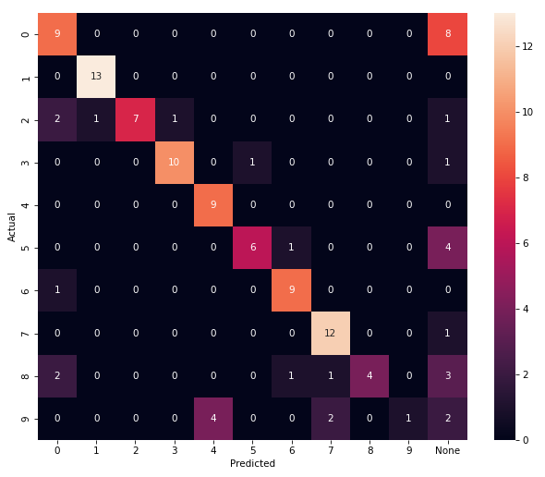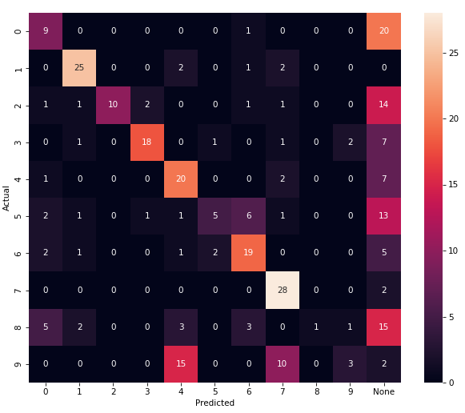

F1_score (train): 0.6838 F1_score (test): 0.46

1. **nn = 50**, n_train = 1000, n_test = 300, k = 0.99, tau_const = 3.5,

g_const = **3.1**/ni(train), **3.5**/ni(clf), **3.5**/ni(test), learning_rate = **0.25**

Training time: 881.2035183906555

Actual number of training set: 160

Number of neurons, reacting to the corresponding image: {'9': 4, '4': 7, '3': 7, '6': 6, '0': 6, '2': 9, '7': 3, '1': 2, '8': 3, '5': 3}

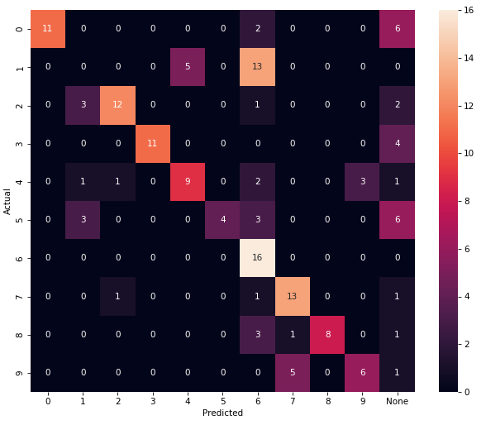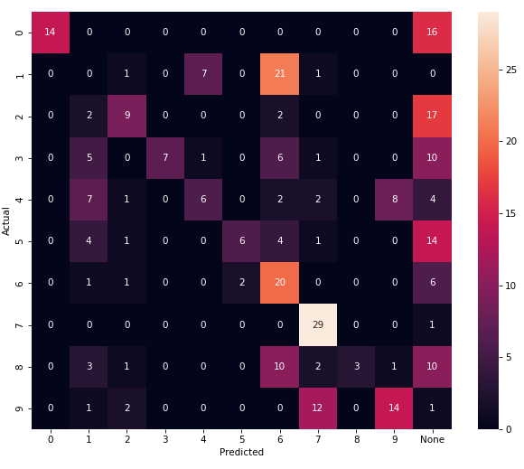

F1_score (train): 0.5625 F1_score (test): 0.36

1. **nn = 60**, n_train = 1000, n_test = 300, k = **0.999**, tau_const = 3.5,

g_const = **3.1**/ni(train), **3.5**/ni(clf), **3.7**/ni(test), learning_rate = **0.25**

Training time: 1202.877905368805

Actual number of training set: 221

Number of neurons, reacting to the corresponding image: {'0': 8, '4': 6, '2': 6, '3': 10, '7': 8, '1': 2, '8': 6, '9': 1, '6': 6, 'None': 1, '5': 6}

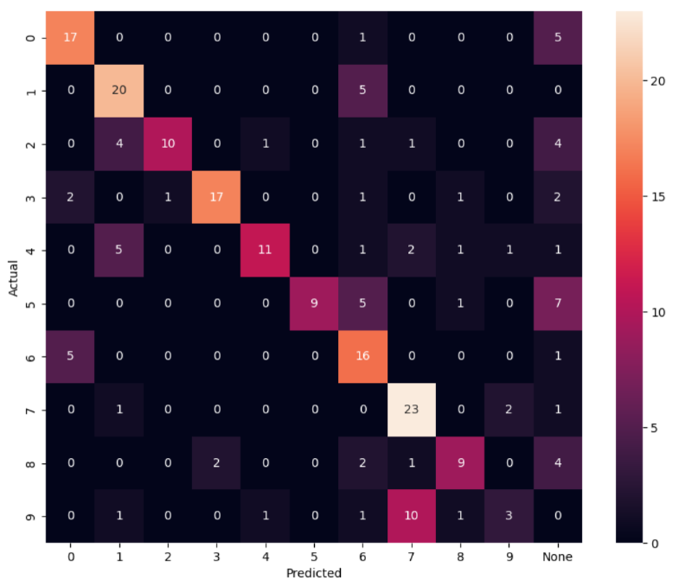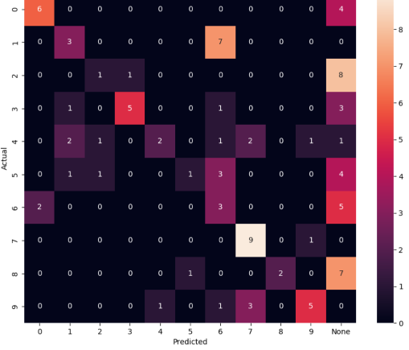

F1_score (train): 0.61 F1_score (test): 0.37

# g_const = **3.1**/ni(train), **3.5**/ni(clf), **3.5**/ni(test)

F1_score train: 0.5746 F1_score test: 0.33

# g_const = **3.0**/ni(train), **3.5**/ni(clf), **3.5**/ni(test)

F1_score train: 0.595 F1_score test: 0.38

1. **nn = 70**, n_train = 1000, n_test = 300, k = **0.999**, tau_const = 3.5,

g_const = **3.0**/ni(train), **3.5**/ni(clf), **3.7**/ni(test), learning_rate = **0.25**

Training time: 1510.4989705085754

Actual number of training set: 303

Number of neurons, reacting to the corresponding image: {'9': 6, '1': 6, '2': 12, '3': 9, '7': 6, '4': 11, 'None': 2, '8': 5, '6': 6, '5': 5, '0': 2}

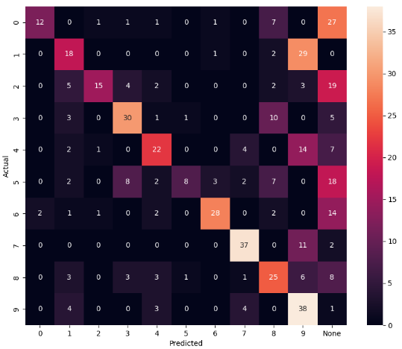

F1_score (train): 0.5775 F1_score (test): 0.466

# g_const = **3.1**/ni(train), **3.5**/ni(clf), **3.7**/ni(test)

F1_score train: 0.541 F1_score test: 0.498

# g_const = **3.0**/ni(train), **3.5**/ni(clf), **3.5**/ni(test)

F1_score train: 0.56 F1_score test: 0.42

1. **nn = 80**, n_train = 1000, n_test = 300, k = **0.999**, tau_const = 3.5,

g_const = **3.1**/ni(train), **3.5**/ni(clf), **3.7**/ni(test), learning_rate = **0.25**

Training time: 1921.6721680164337

Actual number of training set: 267

Number of neurons, reacting to the corresponding image: {'0': 6, '6': 11, '5': 11, '2': 8, '3': 11, '7': 4, '4': 12, '1': 4, '8': 7, '9': 6}

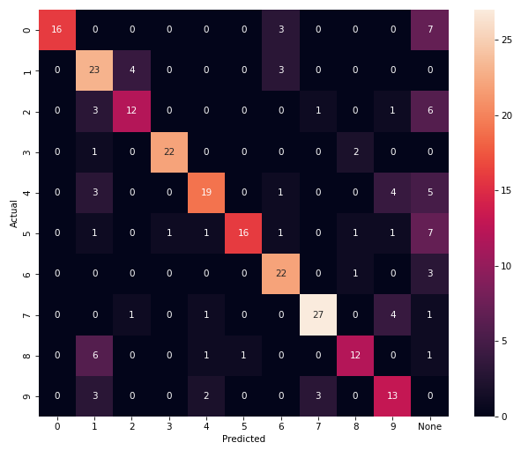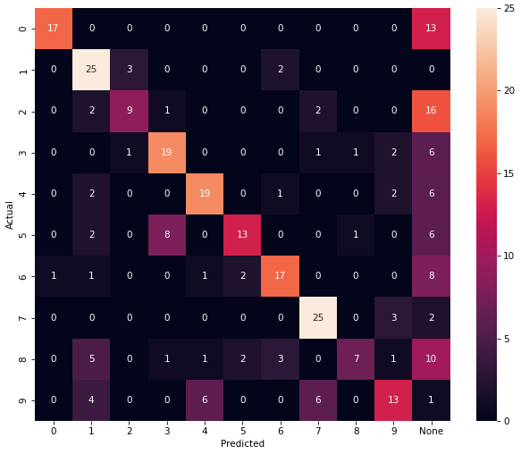

F1_score (train): 0.6816 F1_score (test): 0.5467

1. **nn = 90**, n_train = 1000, n_test = 300, k = **0.999**, tau_const = 3.5,

g_const = **3.1**/ni(train), **3.5**/ni(clf), **3.7**/ni(test), learning_rate = **0.25**

Training time: 6236.987206220627

Actual number of training set: 430

Number of neurons, reacting to the corresponding image: {'None': 10, '8': 10, '3': 11, '4': 15, '2': 11, '5': 7, '7': 4, '0': 8, '6': 8, '9': 3, '1': 3}

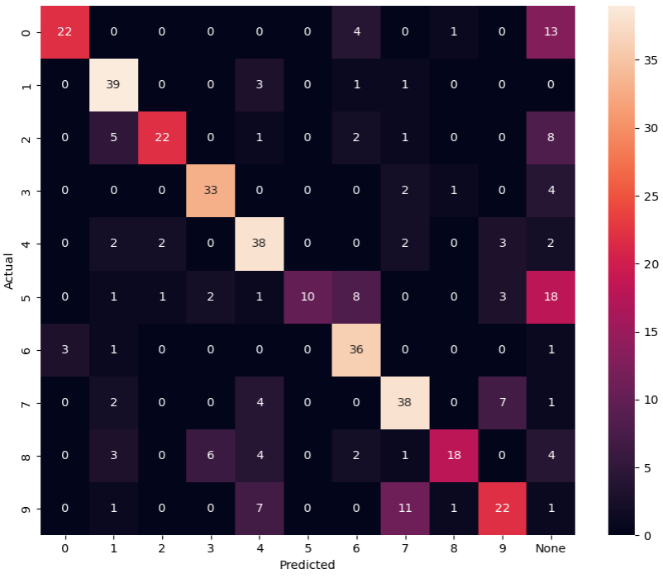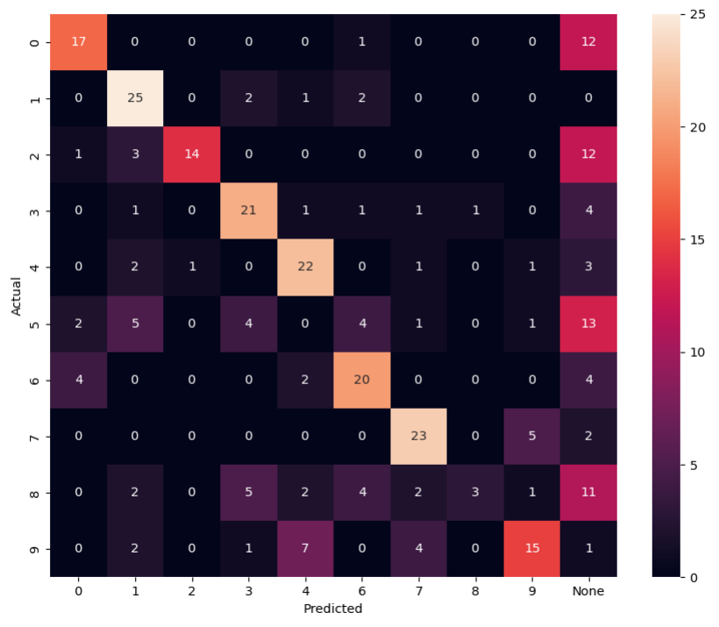

F1_score (train): 0.6465 F1_score (test): 0.5333

1. **nn = 100**, n_train = 1000, n_test = 300, k = **0.999**, tau_const = 3.5,

g_const = **3.1**/ni(train), **3.5**/ni(clf), **3.7**/ni(test), learning_rate = **0.25**

Training time: 2812.6743059158325

Actual number of training set: 476

Number of neurons, reacting to the corresponding image: {'0': 8, '8': 17, '2': 12, '9': 5, '1': 4, '3': 13, '4': 11, '6': 13, '5': 9, '7': 6, 'None': 2}

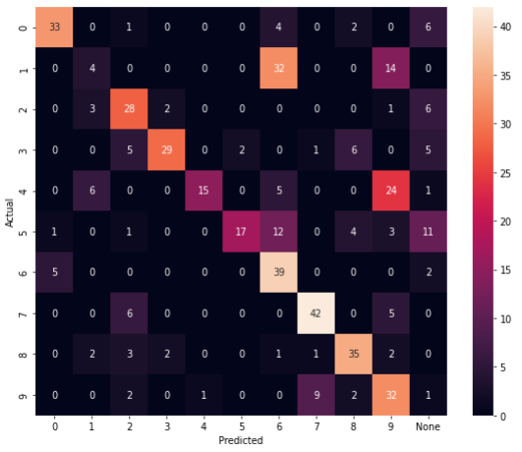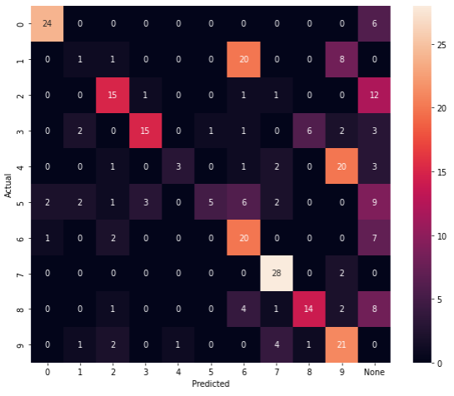

F1_score (train): 0.5756 F1_score (test): 0.4866

Number of neurons, reacting to the corresponding image: {'2': 15, '0': 11, '4': 17, '1': 4, '6': 9, '8': 11, '3': 13, '9': 4, '5': 9, '7': 7}

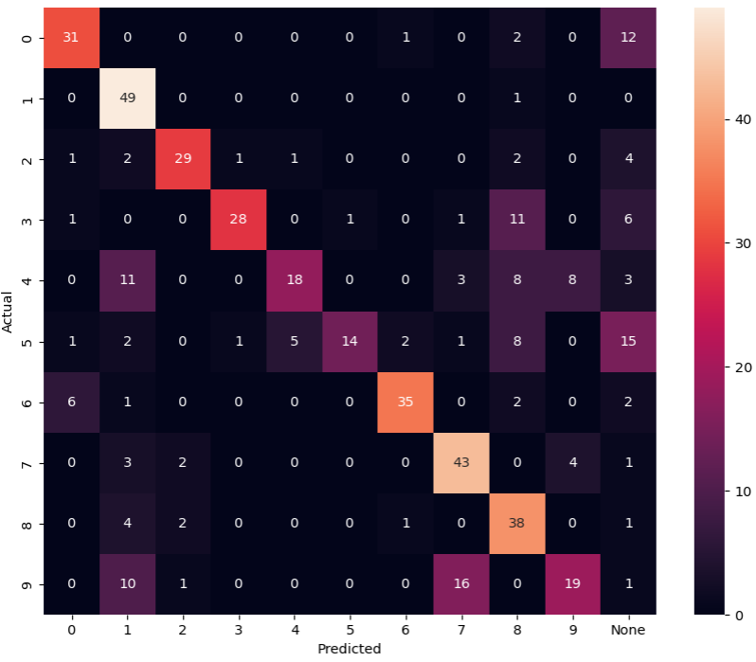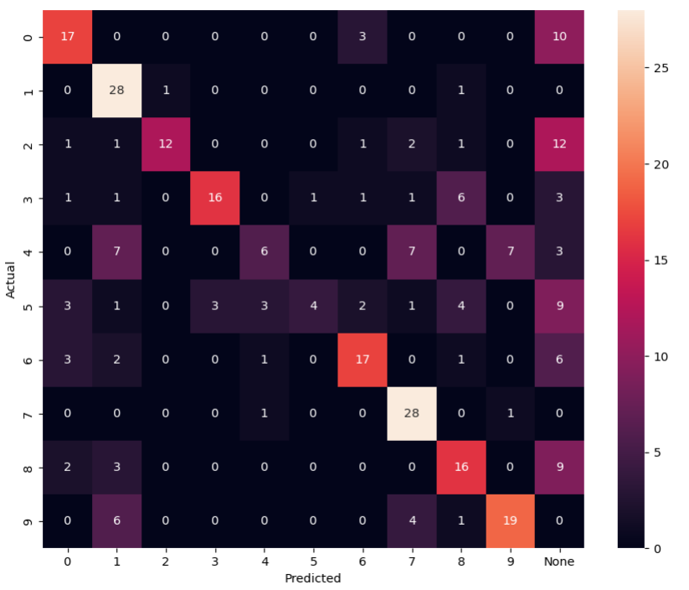

F1_score (train): 0.6387 F1_score (test): 0.5433

1. **nn = 110**, n_train = 1000, n_test = 300, k = **0.999**, tau_const = 3.5,

g_const = **3.1**/ni(train), **3.5**/ni(clf), **3.7**/ni(test), learning_rate = **0.25**

Training time: 5343.773236751556

Actual number of training set: 476

Number of neurons, reacting to the corresponding image: {'6': 13, '5': 8, '4': 19, '7': 9, '0': 11, '2': 7, '9': 11, '8': 17, '3': 12, 'None': 1, '1': 2}

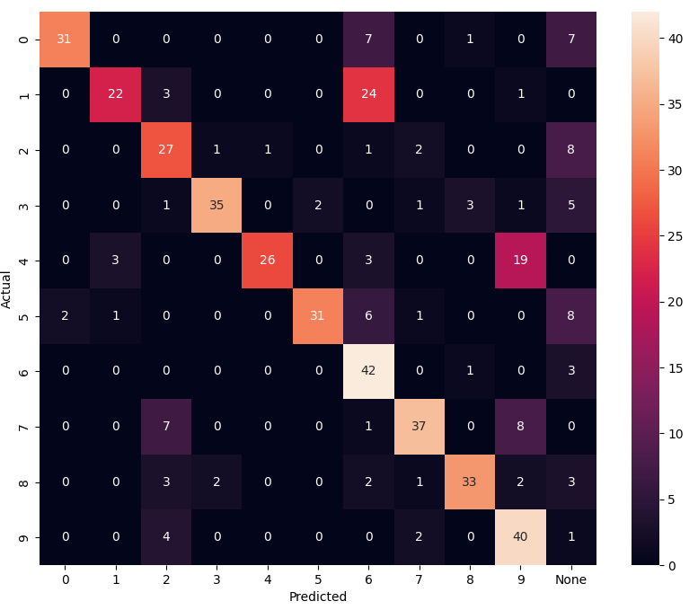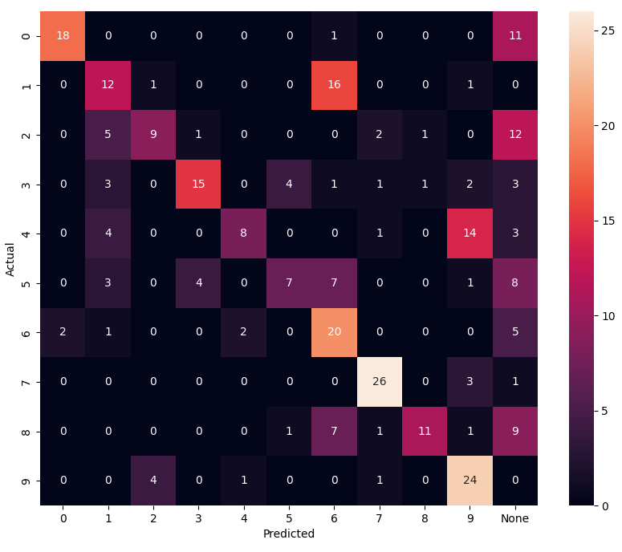

F1_score (train): 0.68 F1_score (test): 0.5

1. **nn = 120**, n_train = 1000, n_test = 300, k = **0.999**, tau_const = 3.5,

g_const = **3.1**/ni(train), **3.5**/ni(clf), **3.7**/ni(test), learning_rate = **0.25**

Training time: 4666.2058618068695

Actual number of training set: 593

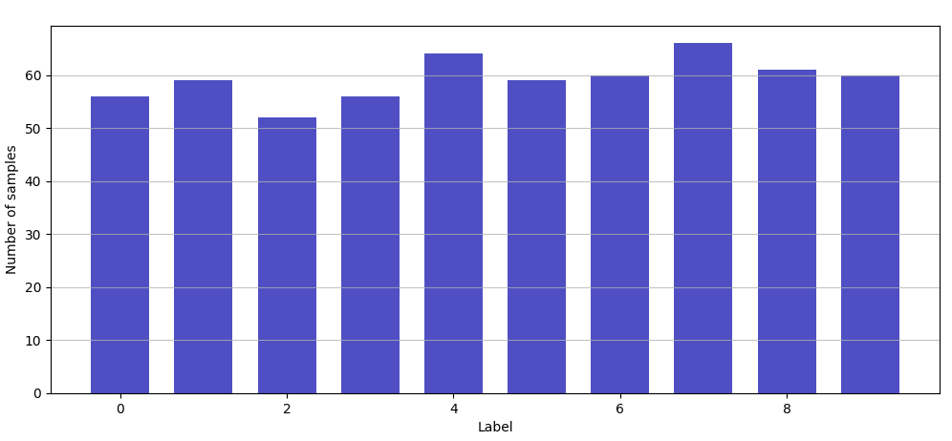

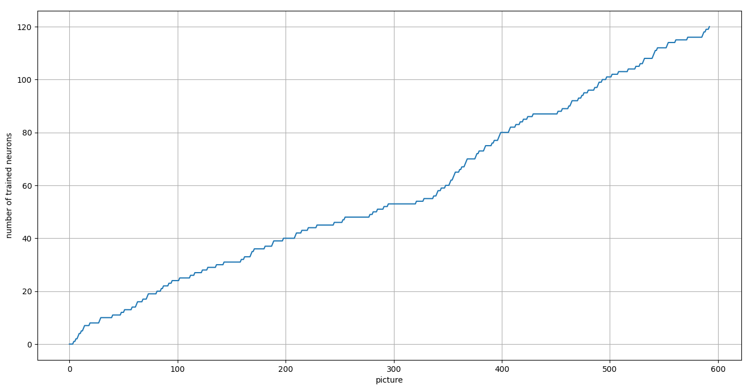

Number of neurons, reacting to the corresponding image: {'3': 13, '5': 15, '7': 7, '8': 18, '2': 16, '0': 13, '1': 3, '6': 14, '4': 14, '9': 7}

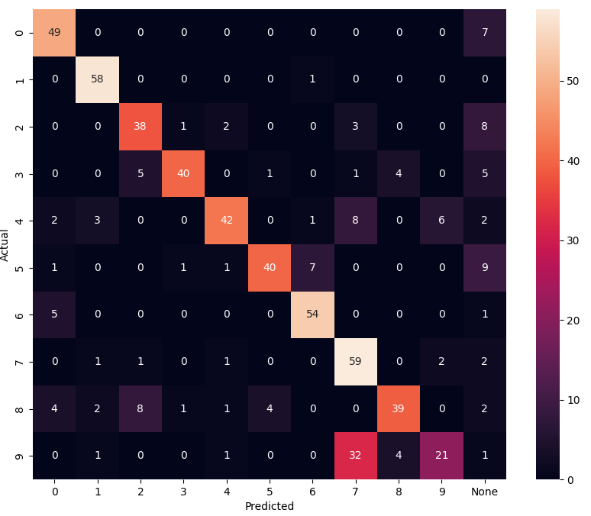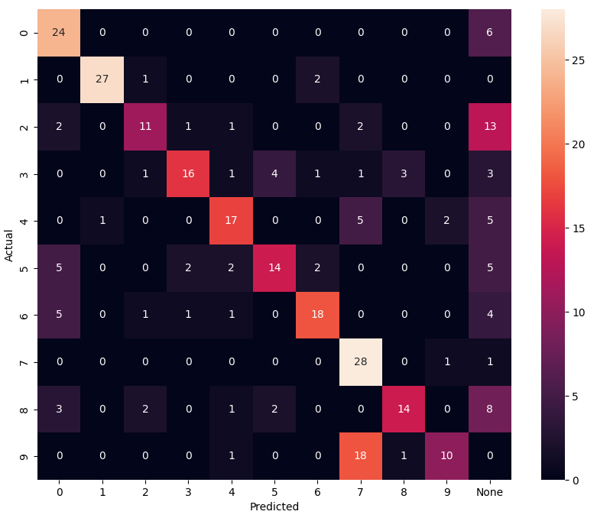

F1_score (train): 0.7420 F1_score (test): 0.5967

1. **nn = 130**, n_train = 1000, n_test = 300, k = **0.999**, tau_const = 3.5,

g_const = **3.1**/ni(train), **3.5**/ni(clf), **3.7**/ni(test), learning_rate = **0.25**

Training time: 6235.424516677856

Actual number of training set: 738

Number of neurons, reacting to the corresponding image: {'3': 18, '5': 21, '1': 3, '8': 13, '0': 15, '2': 15, '7': 7, '4': 15, '9': 8, '6': 13, 'None': 2}

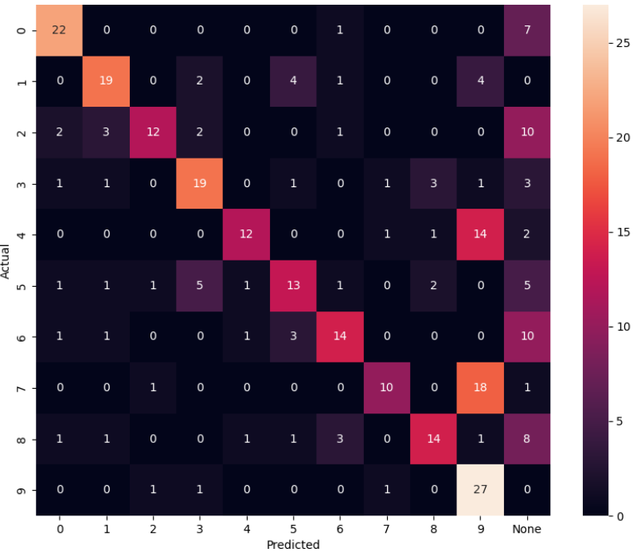

F1_score (train): 0.68 F1_score (test): 0.54

g_const = **3.1**/ni(train), **4.0**/ni(clf), **3.7**/ni(test)

Training time: 5489.490008354187

Actual number of training set: 619

Number of neurons, reacting to the corresponding image: {'2': 14, 'None': 31, '8': 11, '6': 10, '5': 10, '3': 11, '4': 21, '0': 6, '7': 8, '1': 5, '9': 3}

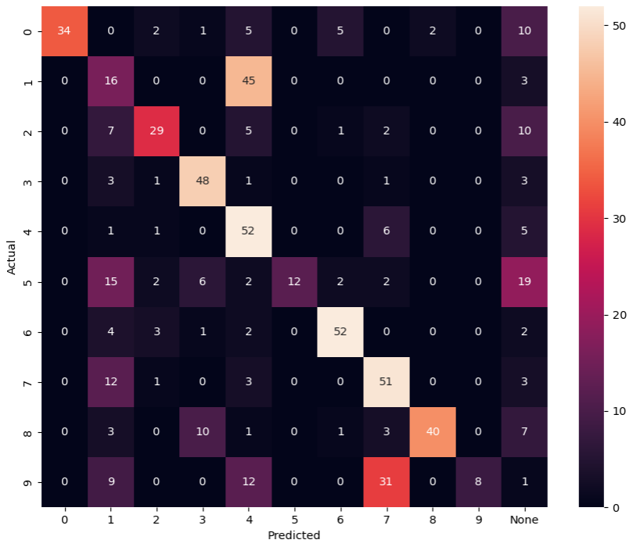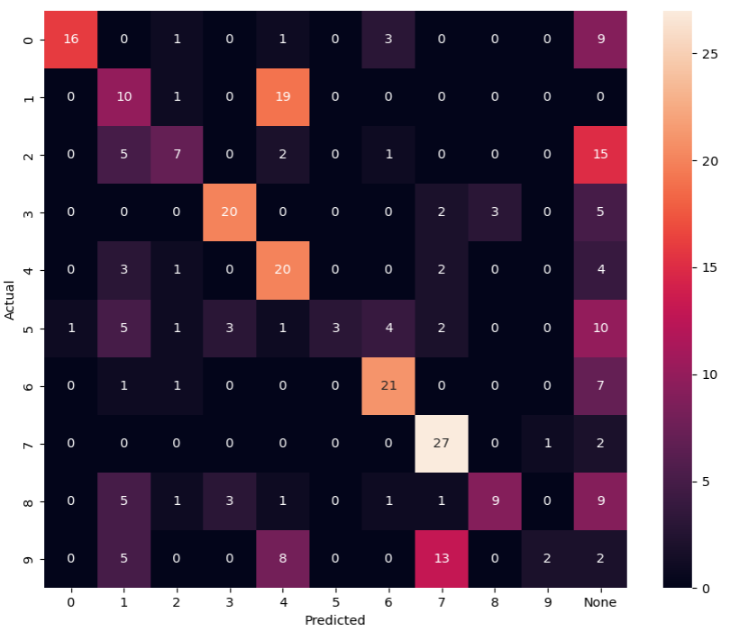

F1_score (train): 0.5525 F1_score (test): 0.45

1. **nn = 140**, n_train = 3000, n_test = 300, k = **0.999**, tau_const = 3.5,

g_const = **3.1**/ni(train), **3.5**/ni(clf), **3.7**/ni(test), learning_rate = **0.25**

Training time: 9051.91522693634

Actual number of training set: 709

Number of neurons, reacting to the corresponding image: {'9': 11, '3': 17, '7': 14, '5': 19, '4': 15, '0': 12, '2': 16, '6': 12, '8': 16, '1': 5, 'None': 3}

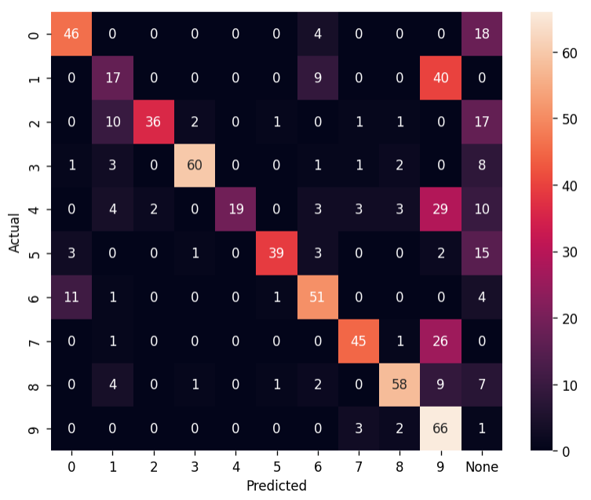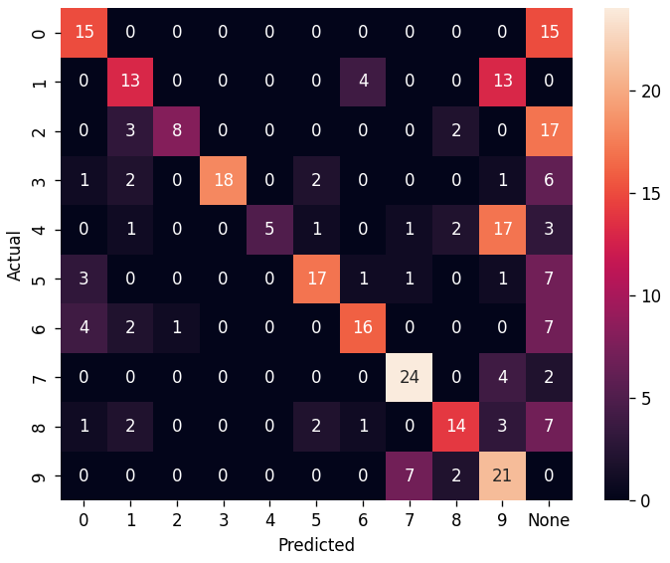

F1_score (train): 0.6164 F1_score (test): 0.5033

1. **nn = 150**, n_train = 1000, n_test = 300, k = **0.999**, tau_const = 3.5,

g_const = **3.1**/ni(train), **3.5**/ni(clf), **3.7**/ni(test), learning_rate = **0.25**

Training time: 13149.339324951172

Actual number of training set: 995

Number of neurons, reacting to the corresponding image: {'4': 23, '6': 15, '2': 18, '3': 22, '5': 16, '8': 17, '7': 8, '0': 9, '1': 7, 'None': 5, '9': 10}

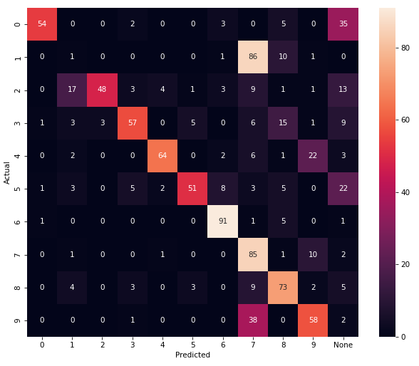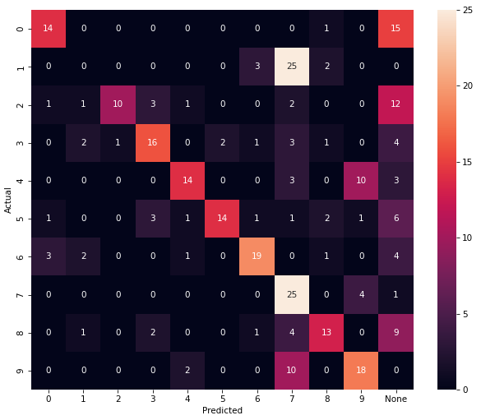

F1_score (train): 0.5849 F1_score (test): 0.4767

1. **nn = 160**, n_train = 3000, n_test = 300, k = **0.999**, tau_const = 3.5,

g_const = **3.1**/ni(train), **3.5**/ni(clf), **3.7**/ni(test), learning_rate = **0.25**

Training time: 7981.408655643463

Actual number of training set: 793

Number of neurons, reacting to the corresponding image: {'None': 7, '0': 15, '3': 21, '8': 22, '5': 21, '4': 14, '2': 18, '9': 13, '7': 12, '6': 13, '1': 4}

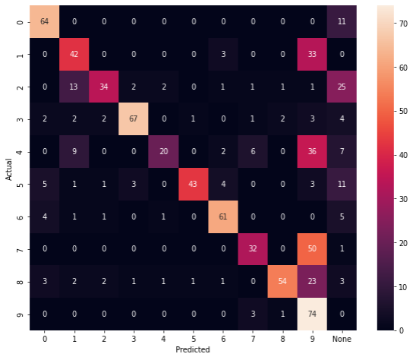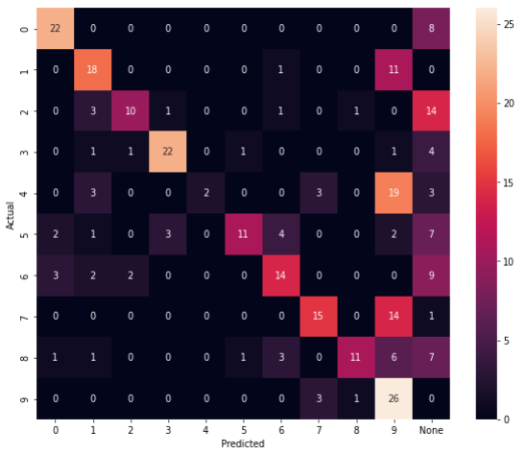

F1_score (train): 0.6192 F1_score (test): 0.5033

1. **nn = 170**, n_train = 3000, n_test = 300, k = **0.999**, tau_const = 3.5,

g_const = **3.1**/ni(train), **3.5**/ni(clf), **3.7**/ni(test), learning_rate = **0.25**

Training time: 10583.720913171768

Actual number of training set: 985

Number of neurons, reacting to the corresponding image: {'1': 7, '5': 21, '7': 15, '3': 23, '8': 22, '4': 16, '2': 16, '0': 15, '9': 15, '6': 12, 'None': 8}

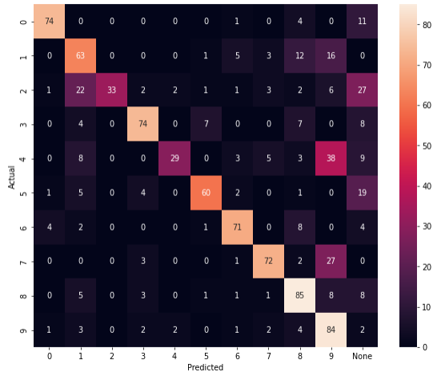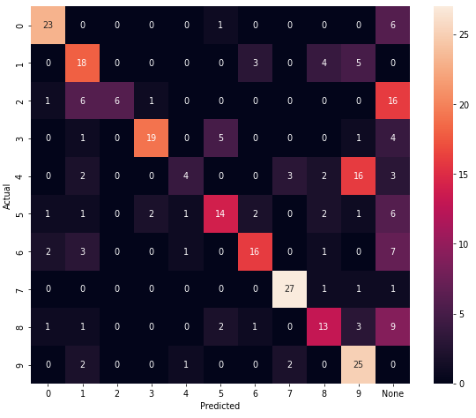

F1_score (train): 0.6548 F1_score (test): 0.55

1. **nn = 180**, n_train = 3000, n_test = 300, k = **0.999**, tau_const = 3.5,

g_const = **3.1**/ni(train), **3.5**/ni(clf), **3.7**/ni(test), learning_rate = **0.25**

Training time: 11570.715314865112

Actual number of training set: 1015

Number of neurons, reacting to the corresponding image: {'2': 24, '5': 22, 'None': 25, '9': 9, '6': 13, '4': 13, '3': 23, '1': 3, '8': 27, '7': 8, '0': 13}

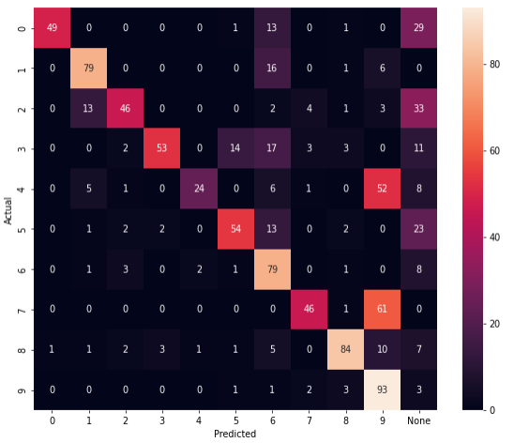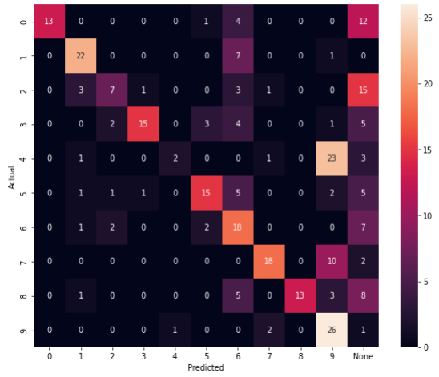

F1_score (train): 0.598 F1_score (test): 0.4967

1. **nn = 190**, n_train = 3000, n_test = 300, k = **0.999**, tau_const = 3.5,

g_const = **3.1**/ni(train), **3.5**/ni(clf), **3.7**/ni(test), learning_rate = **0.25**

Training time: 12354.258126020432

Actual number of training set: 989

Number of neurons, reacting to the corresponding image: {'0': 15, '7': 9, '8': 21, '6': 18, 'None': 28, '5': 32, '4': 16, '3': 18, '2': 21, '1': 2, '9': 10}

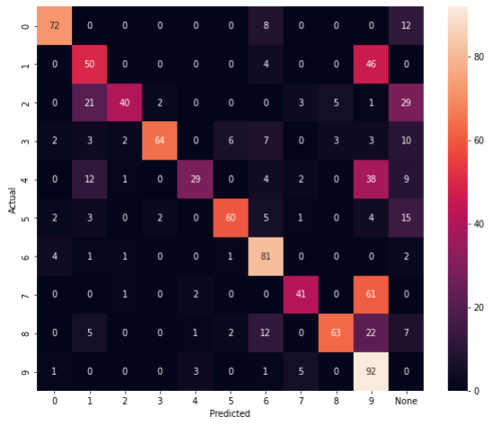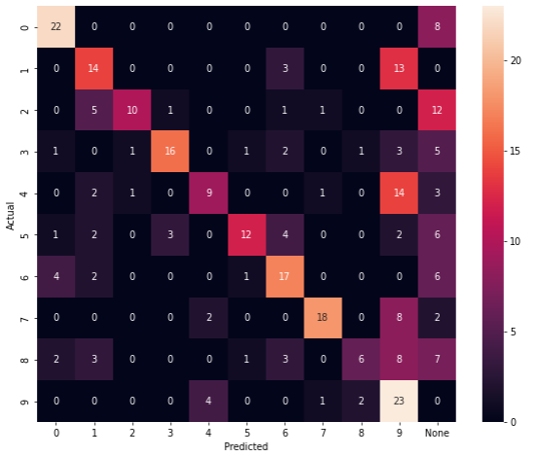

F1_score (train): 0.5986 F1_score (test): 0.49

1. **nn = 200**, n_train = 3000, n_test = 300, k = **0.999**, tau_const = 3.5,

g_const = **3.1**/ni(train), **3.5**/ni(clf), **3.7**/ni(test), learning_rate = **0.25**

Training time: 12437.019114494324

Actual number of training set: 1228

Number of neurons, reacting to the corresponding image: {'None': 32, '2': 23, '3': 24, '5': 27, '4': 19, '8': 22, '7': 9, '6': 22, '0': 12, '9': 8, '1': 2}

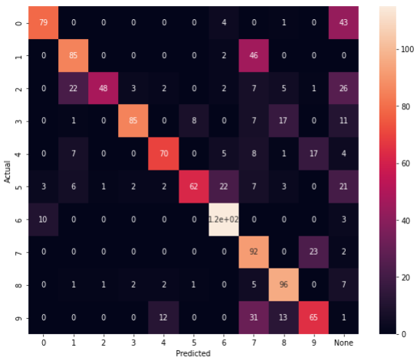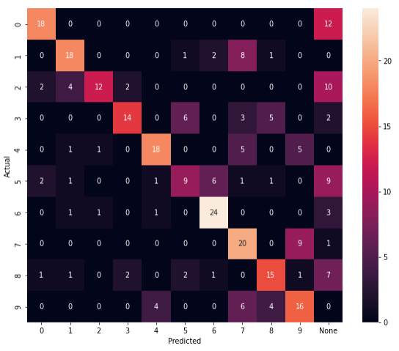

F1_score (train): 0.649 F1_score (test): 0.5467

1. **nn = 210**, n_train = 5000, n_test = 300, k = **0.999**, tau_const = 3.5,

g_const = **3.1**/ni(train), **3.5**/ni(clf), **3.7**/ni(test), learning_rate = **0.25**

Training time: 11501.166670799255

Actual number of training set: 1385

Number of neurons, reacting to the corresponding image: {'4': 30, '8': 16, '2': 27, '0': 27, '5': 25, '3': 23, '6': 25, '9': 12, 'None': 10, '7': 14, '1': 1}

F1_score (train): 0.7011 F1_score (test): 0.5892

1. **nn = 220**, n_train = 5000, n_test = 300, k = **0.999**, tau_const = 3.5,

g_const = **3.1**/ni(train), **3.5**/ni(clf), **3.7**/ni(test), learning_rate = **0.25**

Training time: 13151.511193037033

Actual number of training set: 1547

Number of neurons, reacting to the corresponding image: {'7': 13, '4': 24, '3': 38, '2': 27, '8': 20, '5': 28, '0': 19, 'None': 10, '6': 26, '9': 11, '1': 4}

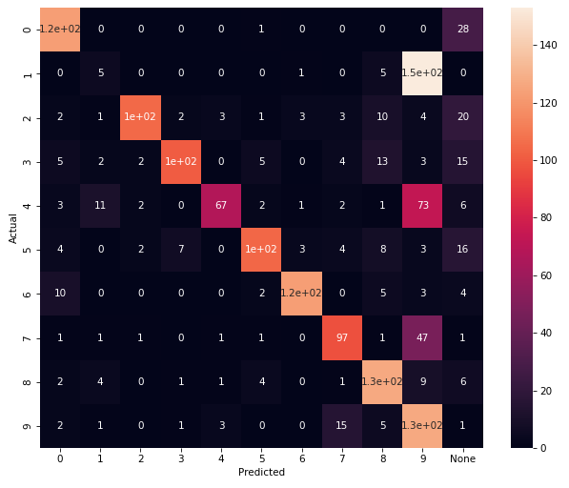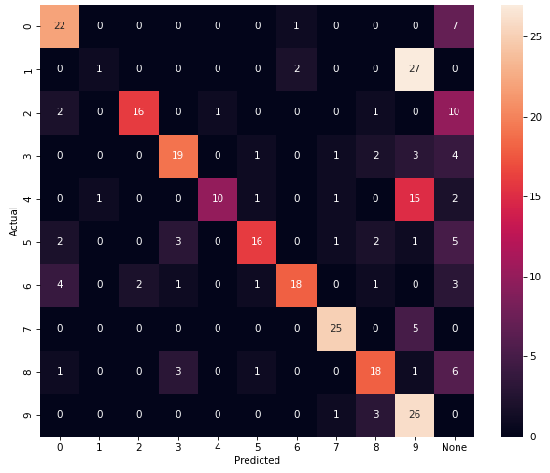

F1_score (train): 0.6328 F1_score (test): 0.57

1. **nn = 230**, n_train = 5000, n_test = 300, k = **0.999**, tau_const = 3.5,

g_const = **3.1**/ni(train), **3.5**/ni(clf), **3.7**/ni(test), learning_rate = **0.25**

Training time: 20866.976009845734

Actual number of training set: 1421

Number of neurons, reacting to the corresponding image: {'4': 22, 'None': 93, '6': 12, '3': 13, '2': 15, '7': 13, '9': 14, '1': 7, '5': 18, '8': 12, '0': 11}

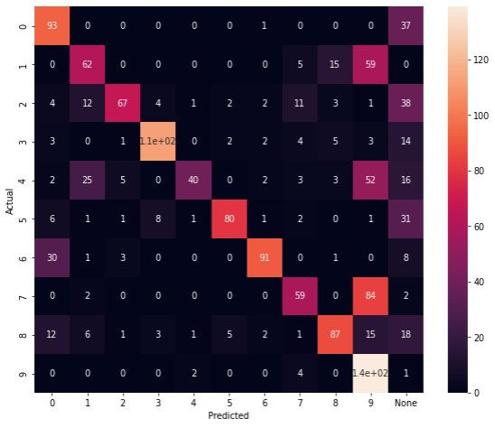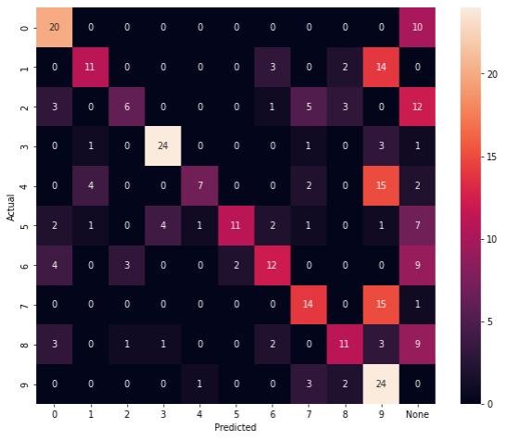

F1_score (train): 0.5841 F1_score (test): 0.4667

1. **nn = 240**, n_train = 5000, n_test = 300, k = **0.999**, tau_const = 3.5,

g_const = **3.1**/ni(train), **3.5**/ni(clf), **3.7**/ni(test), learning_rate = **0.25**

Training time:

Actual number of training set:

Number of neurons, reacting to the corresponding image:

Samples done: 1220 / 5000

F1_score (train): 0. F1_score (test): 0.

1. **nn = 250**, n_train = 5000, n_test = 300, k = **0.999**, tau_const = 3.5,

g_const = **3.1**/ni(train), **3.5**/ni(clf), **3.7**/ni(test), learning_rate = **0.25**

Training time: 25511.82226037979

Actual number of training set: 1631

Number of neurons, reacting to the corresponding image: {'5': 36, '0': 26, '3': 30, '6': 24, 'None': 8, '4': 28, '2': 33, '8': 32, '9': 16, '7': 14, '1': 3}

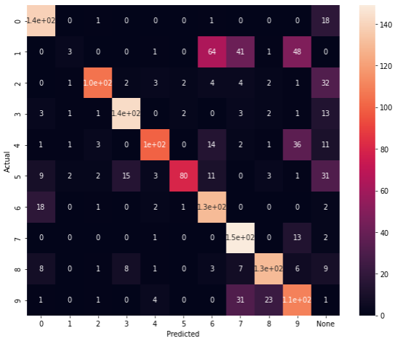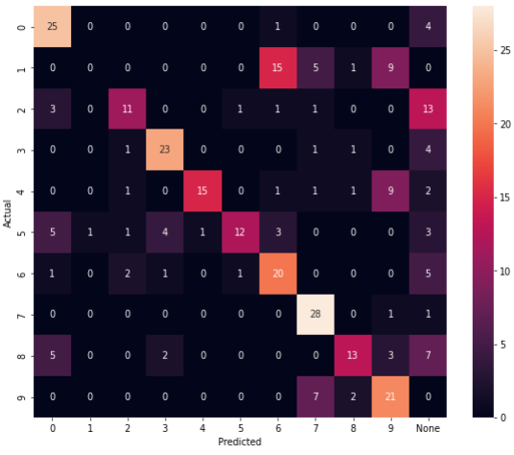

F1_score (train): 0.6677 F1_score (test): 0.56

1. **nn = 260**, n_train = 5000, n_test = 300, k = **0.999**, tau_const = 3.5,

g_const = **3.1**/ni(train), **3.5**/ni(clf), **3.7**/ni(test), learning_rate = **0.25**

Training time:

Actual number of training set:

Number of neurons, reacting to the corresponding image:

Samples done: 1090 / 5000

F1_score (train): 0. F1_score (test): 0.

1. **nn = 270**, n_train = 5000, n_test = 300, k = **0.999**, tau_const = 3.5,

g_const = **3.1**/ni(train), **3.5**/ni(clf), **3.7**/ni(test), learning_rate = **0.25**

Training time: 28673.30401992798

Actual number of training set: 1896

Number of neurons, reacting to the corresponding image: {'2': 33, '3': 32, '4': 35, '8': 32, '6': 22, '5': 35, '7': 13, '0': 31, 'None': 11, '1': 9, '9': 17}

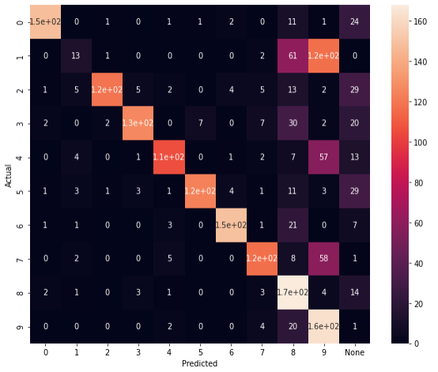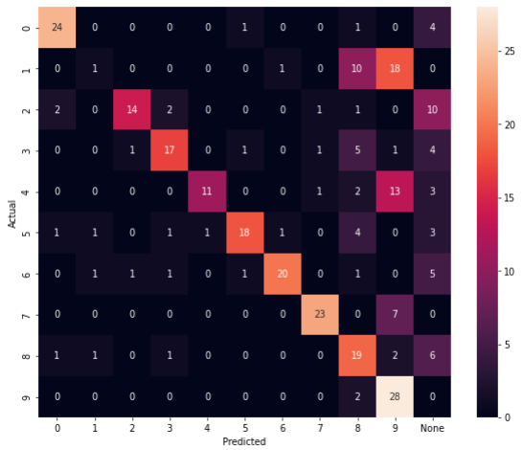

F1_score (train): 0.6503 F1_score (test): 0.5833

1. **nn = 290**, n_train = 5000, n_test = 300, k = **0.999**, tau_const = 3.5,

g_const = **3.1**/ni(train), **3.5**/ni(clf), **3.7**/ni(test), learning_rate = **0.25**

Training time: 33137.87868022919

Actual number of training set: 2049

Number of neurons, reacting to the corresponding image: {'8': 32, '1': 9, '2': 40, '5': 32, '6': 20, '4': 40, '9': 21, '3': 41, '0': 31, '7': 18, 'None': 6}

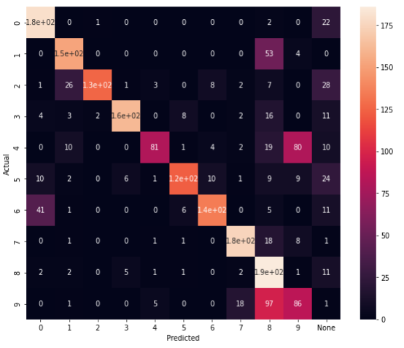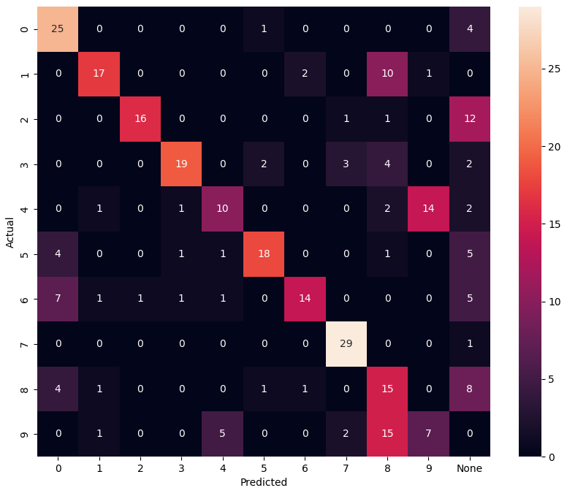

F1_score (train): 0.6862 F1_score (test): 0.5667

1. **nn = 300**, n_train = 3000, n_test = 300, k = **0.999**, tau_const = 3.5,

g_const = **3.1**/ni(train), **3.5**/ni(clf), **3.7**/ni(test), learning_rate = **0.25**

Training time: 69720.40385460854

Actual number of training set: 2172

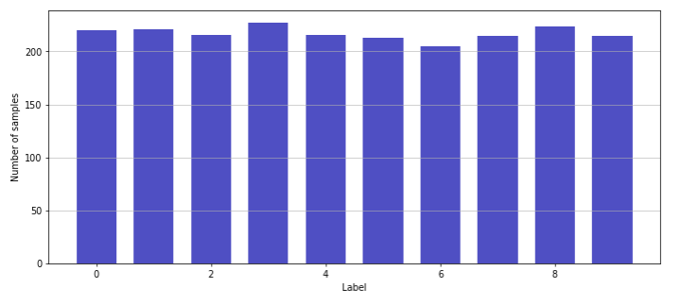

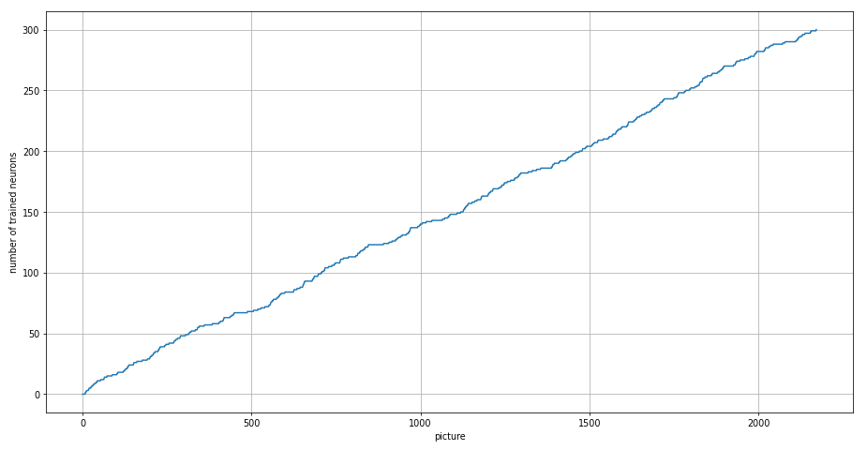

Number of neurons, reacting to the corresponding image: {'1': 6, '6': 31, '0': 29, '3': 42, 'None': 8, '4': 33, '8': 39, '5': 34, '2': 41, '7': 22, '9': 15}

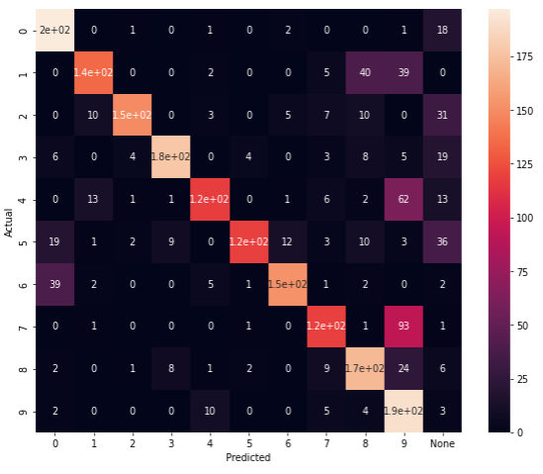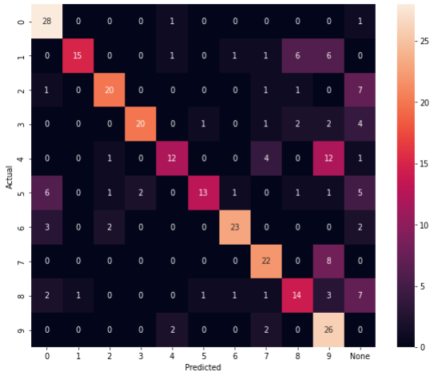

F1_score (train): 0.7035 F1_score (test): 0.6433

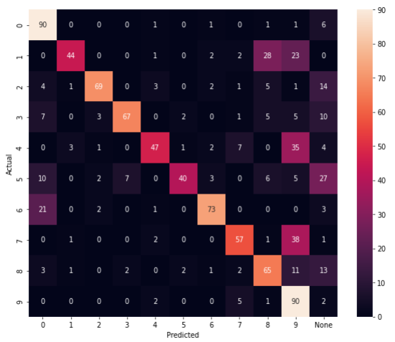

F1_score (test=1000): 0.642

1. **nn = 310**, n_train = 5000, n_test = 300, k = **0.999**, tau_const = 3.5,

g_const = **3.1**/ni(train), **3.5**/ni(clf), **3.7**/ni(test), learning_rate = **0.25**

Training time: 60736.84570646286

Actual number of training set: 2190

Number of neurons, reacting to the corresponding image: {'0': 32, '4': 42, '3': 50, '9': 15, '2': 40, 'None': 9, '1': 8, '7': 16, '6': 29, '5': 40, '8': 29}

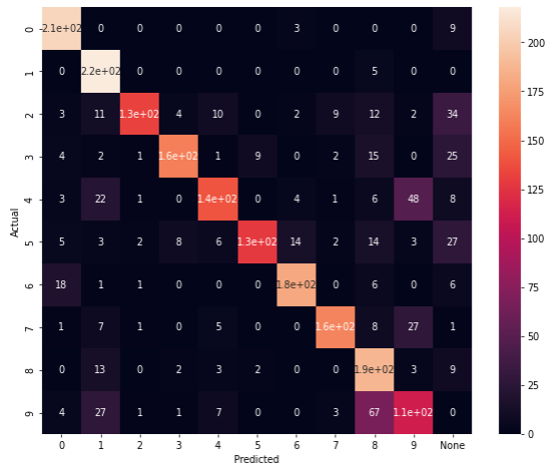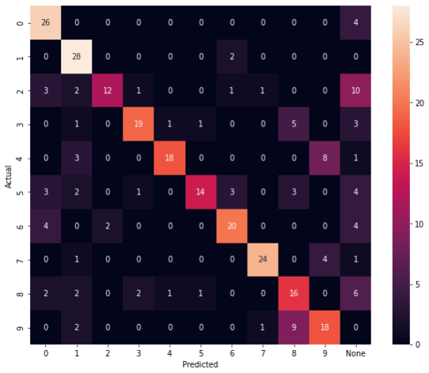

F1_score (train): 0.7425 F1_score (test): 0.65

1. **nn = 320**, n_train = 3000, n_test = 300, k = **0.999**, tau_const = 3.5,

g_const = **3.1**/ni(train), **3.5**/ni(clf), **3.7**/ni(test), learning_rate = **0.25**

Training time: 55978.15587615967

Actual number of training set: 2466

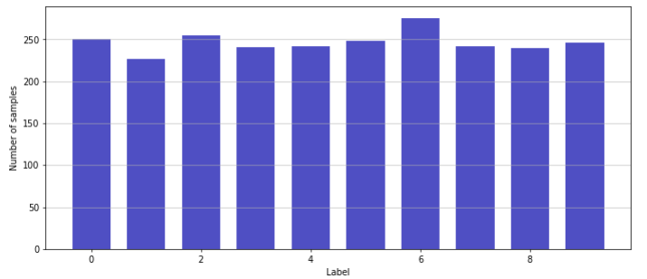

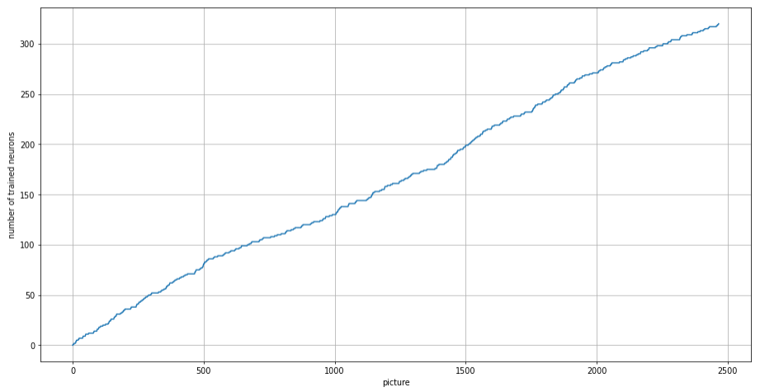

Number of neurons, reacting to the corresponding image: {'6': 24, '3': 28, '8': 39, '7': 21, '2': 42, '4': 39, 'None': 21, '5': 43, '0': 29, '9': 25, '1': 9}

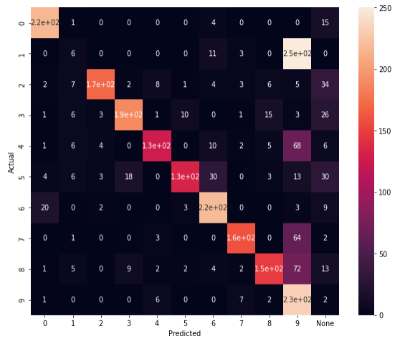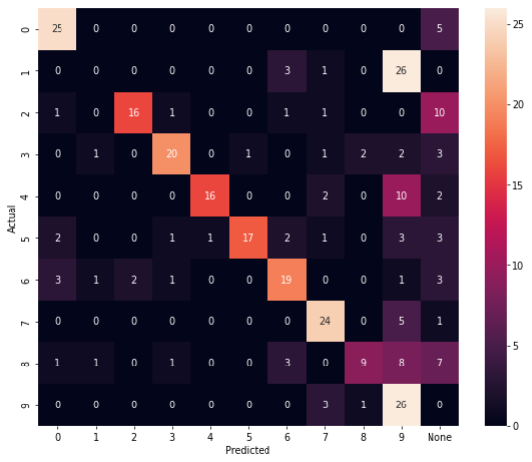

F1_score (train): 0.6488 F1_score (test): 0.5733

1. **nn = 330**, n_train = 3000, n_test = 300, k = **0.999**, tau_const = 3.5,

g_const = **3.1**/ni(train), **3.5**/ni(clf), **3.7**/ni(test), learning_rate = **0.25**

Training time: 62594.89889907837

Actual number of training set: 2584

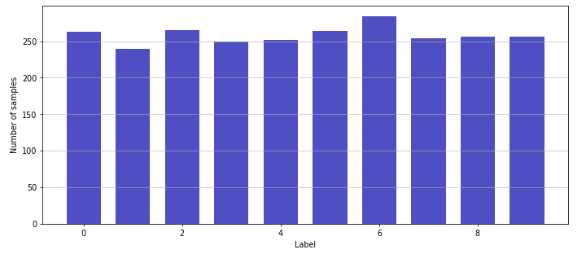

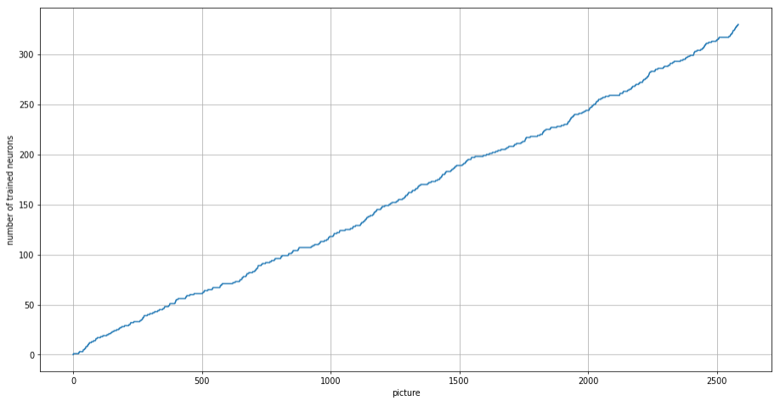

Number of neurons, reacting to the corresponding image: {'3': 31, '4': 42, '0': 33, '2': 33, 'None': 60, '6': 27, '7': 19, '5': 29, '9': 15, '8': 32, '1': 9}

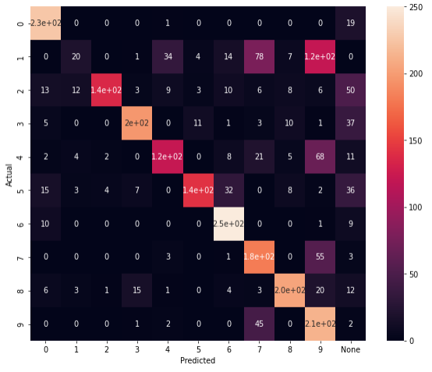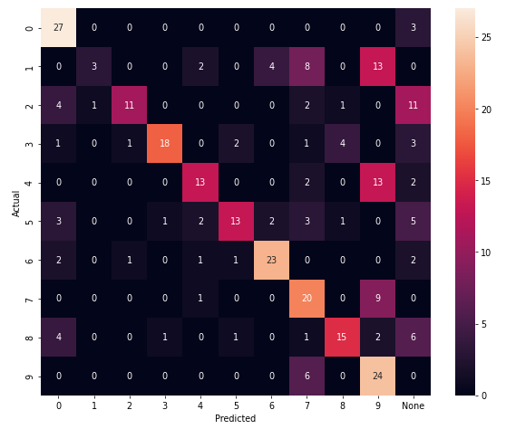

F1_score (train): 0.6548 F1_score (test): 0.5567

1. **nn = 340**, n_train = 5000, n_test = 300, k = **0.999**, tau_const = 3.5,

g_const = **3.1**/ni(train), **3.5**/ni(clf), **3.7**/ni(test), learning_rate = **0.25**

Training time: 83975.98957657814

Actual number of training set: 2726

Number of neurons, reacting to the corresponding image: {'9': 15, '2': 48, 'None': 18, '3': 60, '5': 39, '7': 17, '0': 29, '6': 36, '4': 47, '8': 29, '1': 2}

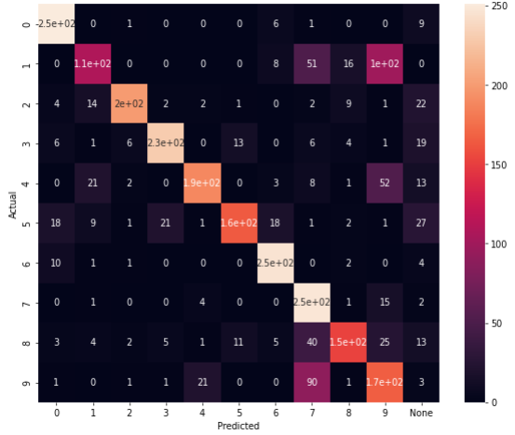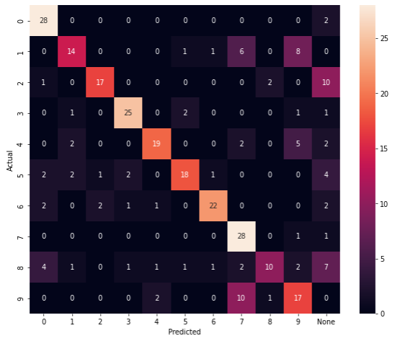

F1_score (train): 0.7168 F1_score (test): 0.66

1. **nn = 350**, n_train = 3000, n_test = 300, k = **0.999**, tau_const = 3.5,

g_const = **3.1**/ni(train), **3.5**/ni(clf), **3.7**/ni(test), learning_rate = **0.25**

Training time: 71450.16793394089

Actual number of training set: 2801

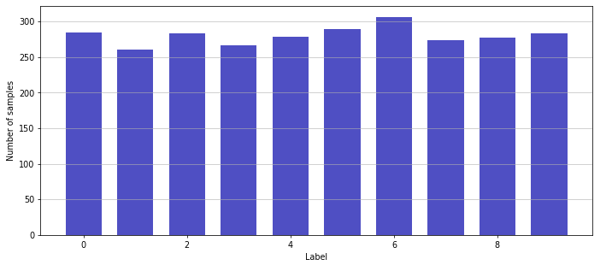

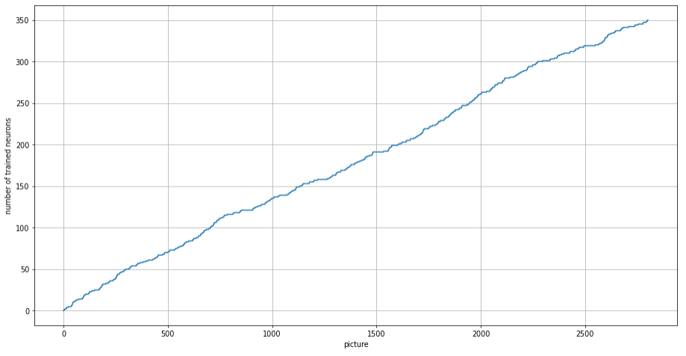

Number of neurons, reacting to the corresponding image: {'None': 128, '5': 27, '4': 36, '3': 28, '9': 15, '2': 30, '8': 31, '7': 12, '0': 21, '6': 20, '1': 2}

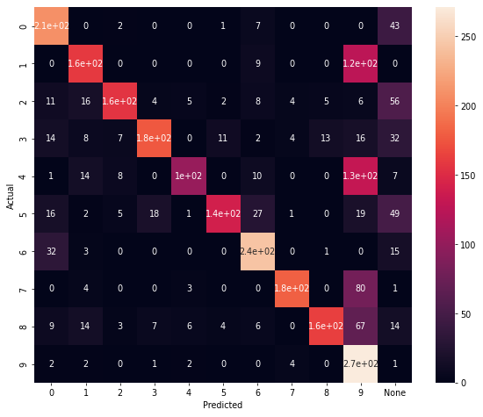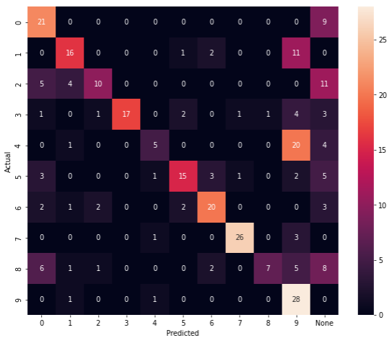

F1_score (train): 0.6426 F1_score (test): 0.55

1. **nn = 360**, n_train = 5000, n_test = 300, k = **0.999**, tau_const = 3.5,

g_const = **3.1**/ni(train), **3.5**/ni(clf), **3.7**/ni(test), learning_rate = **0.25**

Training time: 95795.16010475159

Actual number of training set: 2921

Number of neurons, reacting to the corresponding image: {'4': 43, '6': 42, '0': 38, '7': 23, '2': 51, '3': 57, '8': 35, '5': 45, '9': 12, 'None': 11, '1': 3}

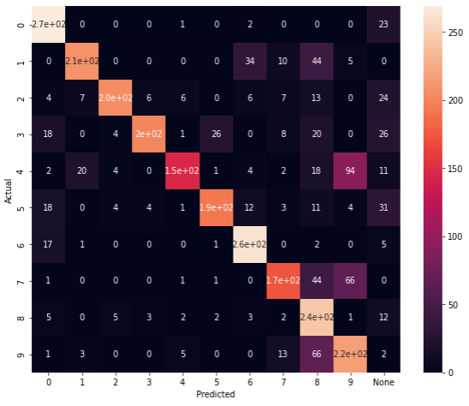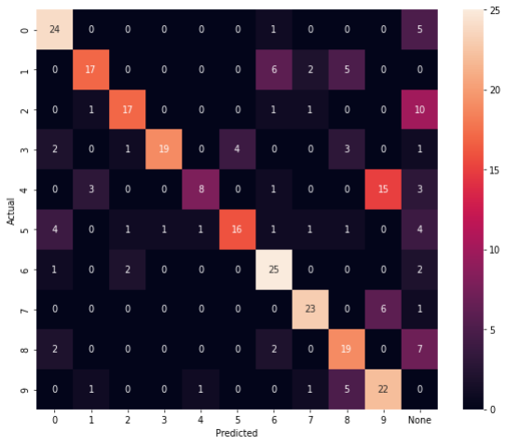

F1_score (train): 0.7251 F1_score (test): 0.6333

1. **nn = 370**, n_train = 5000, n_test = 300, k = **0.999**, tau_const = 3.5,

g_const = **3.1**/ni(train), **3.5**/ni(clf), **3.7**/ni(test), learning_rate = **0.25**

Training time: 112728.15028572083

Actual number of training set: 3441

Number of neurons, reacting to the corresponding image: {'5': 59, '3': 54, '8': 38, '0': 36, '2': 60, '7': 26, '6': 32, '4': 42, '9': 12, 'None': 10, '1': 1}

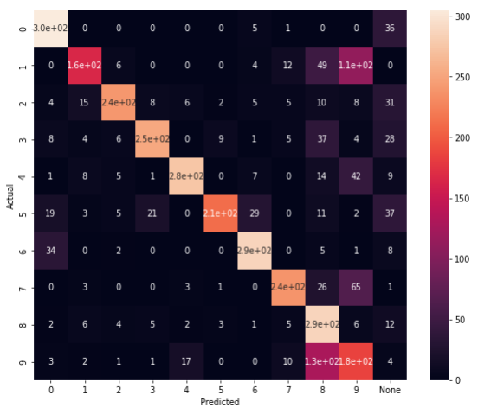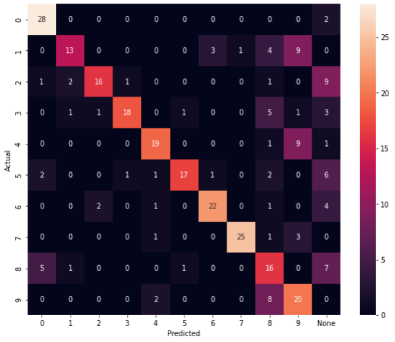

F1_score (train): 0.7108 F1_score (test): 0.6467

Статья:

1. сравнить с PCA, kmeans, STDP + классификатор
2. добавить сверху классификатор, сравнить результаты с ним и без него
3. текст про результаты на USPS и про пункты 1-2
4. картинки на английском

К диплому:

1. график точности в зависимости от числа нейронов

На будущее:

1. <https://wandb.ai/site> прикольный сайт для сохранения данных об экспериментах
2. почитать инфу про то, какие есть методы уменьшения скорости обучения нейронов; сделать так, чтобы k зависело от количества подаваемых картинок. \\ в реальных задачах, когда мало данных, очень важно их всех использовать